Introduction

SPSS Statistics is a software package used for statistical analysis. Long

produced by SPSS Inc., it was acquired by IBM in 2009. The current

versions (2014) are officially named IBM SPSS Statistics.

SPSS is a widely used program for statistical analysis in social science. It

is also used by market researchers, health researchers, survey companies,

government, education researchers, marketing organizations, data miners,

and others.

The many features of SPSS Statistics are accessible via pull-down menus

or can be programmed with a proprietary 4GL command syntax language.

Command syntax programming has the benefits of reproducibility,

simplifying repetitive tasks, and handling complex data manipulations and

analyses. Additionally, some complex applications can only be programmed

in syntax and are not accessible through the menu structure. The pull-down

menu interface also generates command syntax; this can be displayed in the

output, although the default settings have to be changed to make the

syntax visible to the user. They can also be pasted into a syntax file using

the "paste" button present in each menu.

SPSS Statistics places constraints on internal file structure, data types,

data processing, and matching files, which together considerably simplify

programming. SPSS datasets have a two-dimensional table structure,

where the rows typically represent cases (such as individuals or households)

and the columns represent measurements (such as age, sex, or household

income). Only two data types are defined: numeric and text (or "string").

All data processing occurs sequentially case-by-case through the file. Files

can be matched one-to-one and one-to-many, but not many-to-many.

The graphical user interface has two views which can be toggled by clicking

on one of the two tabs in the bottom left of the SPSS Statistics window.

The 'Data View' shows a spreadsheet view of the cases (rows) and

variables (columns). Unlike spreadsheets, the data cells can only contain

numbers or text, and formulas cannot be stored in these cells. The 'Variable

View' displays the metadata dictionary where each row represents a

variable and shows the variable name, variable label, value label(s), print

width, measurement type, and a variety of other characteristics. Cells in

both views can be manually edited, defining the file structure and allowing

data entry without using command syntax. This may be sufficient for small

datasets. Larger datasets such as statistical surveys are more often

created in data entry software, or entered during computer-assisted

personal interviewing, by scanning and using optical character recognition

and optical mark recognition software, or by direct capture from online

questionnaires. These datasets are then read into SPSS.

SPSS Statistics can read and write data from ASCII text files (including

hierarchical files), other statistics packages, spreadsheets and databases.

Applications of SPSS in Various Fields

SPSS finds its uses in various fields with one basic application ie. to hold

and analyze huge amount of data.

It is used in fields such as:

1. Stock Exchange

2. Used by Cosmologists

3. Analyzing Census Data

4. Marketing

5. Survey Companies

6. Other Purposes Include Educational researches, etc.

Index

|  |  |  |  |
| --- | --- | --- | --- |
| S. No. | Title | Date | Sign |
|  |  |  |  |
|  |  |  |  |
|  |  |  |  |
|  |  |  |  |
|  |  |  |  |
|  |  |  |  |
|  |  |  |  |
|  |  |  |  |
|  |  |  |  |
|  |  |  |  |
|  |  |  |  |
|  |  |  |  |
|  |  |  |  |
|  |  |  |  |
|  |  |  |  |

Objective 1: Transportation of Data to SPSS Editor

Inputs: HarryPotter.xlsx, Data File.txt

# Procedure Followed

## Through Excel

**Commands:-**

1. Fie -> Open -> Data

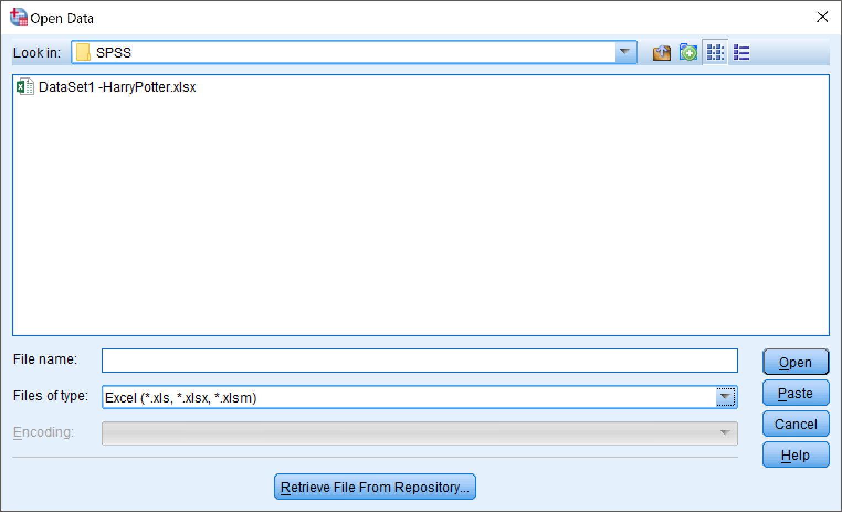

1. Select File

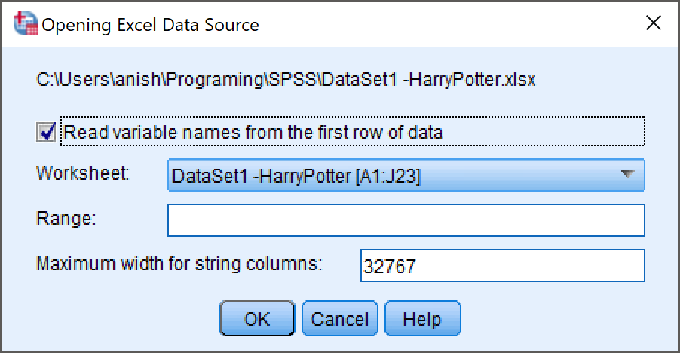

**Output:-**

File: HarryPotter.sav

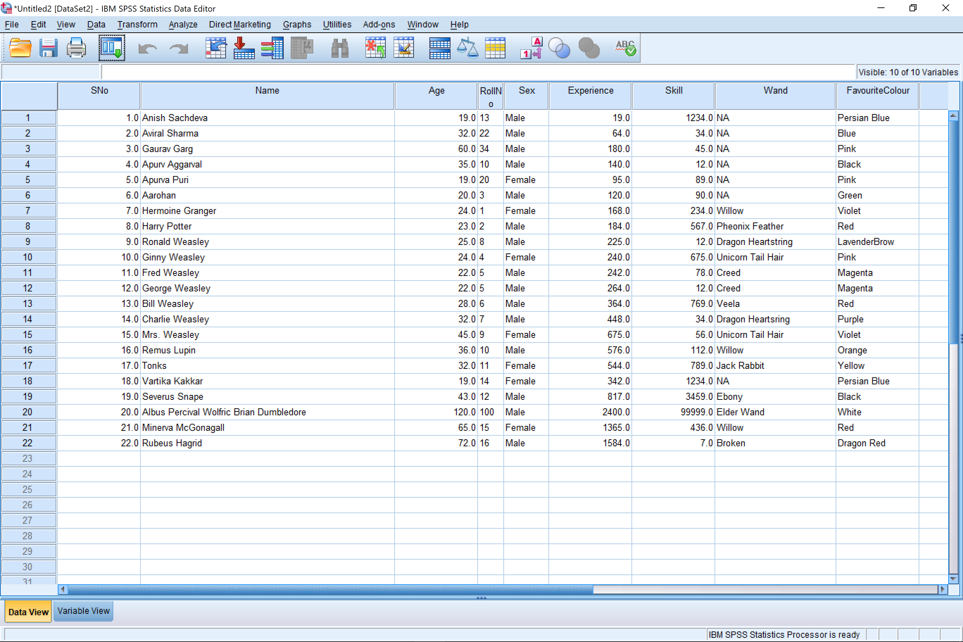

*Data View*

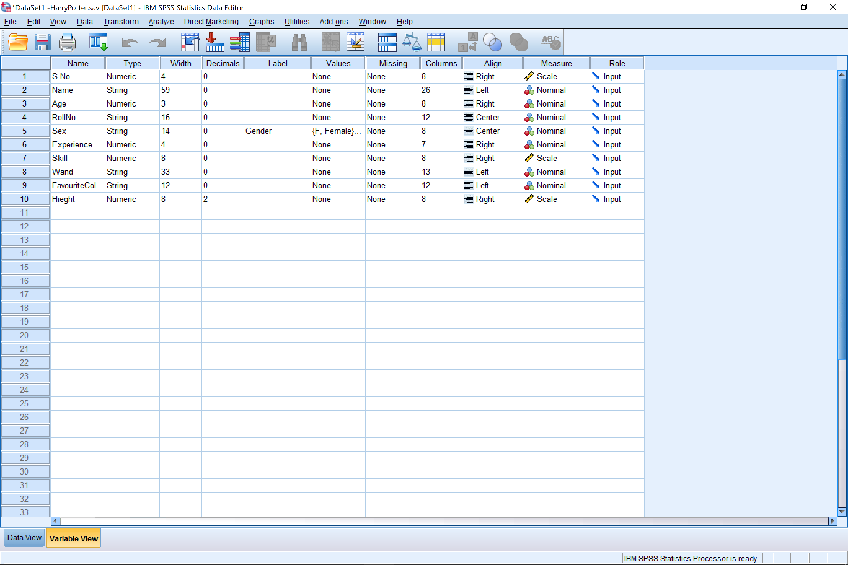

*Variable View*

## Through Text File

**Commands:-**

1. File -> Read Text Data

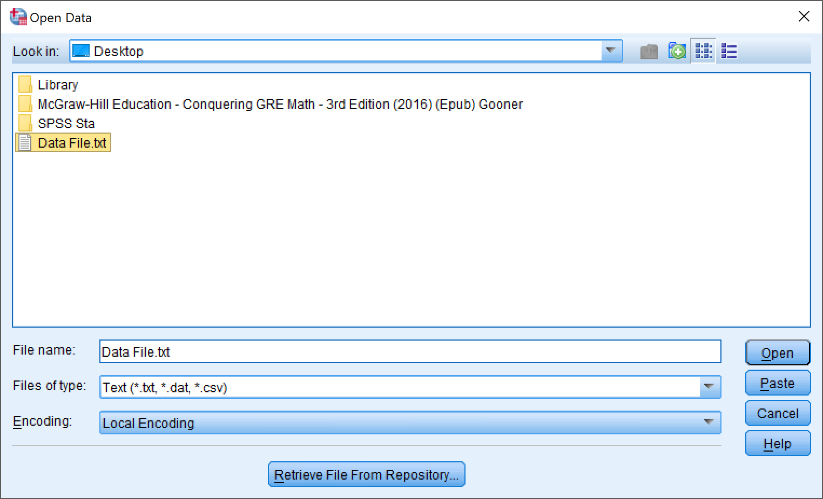

1. Select File -> Complete Text File Import Wizard

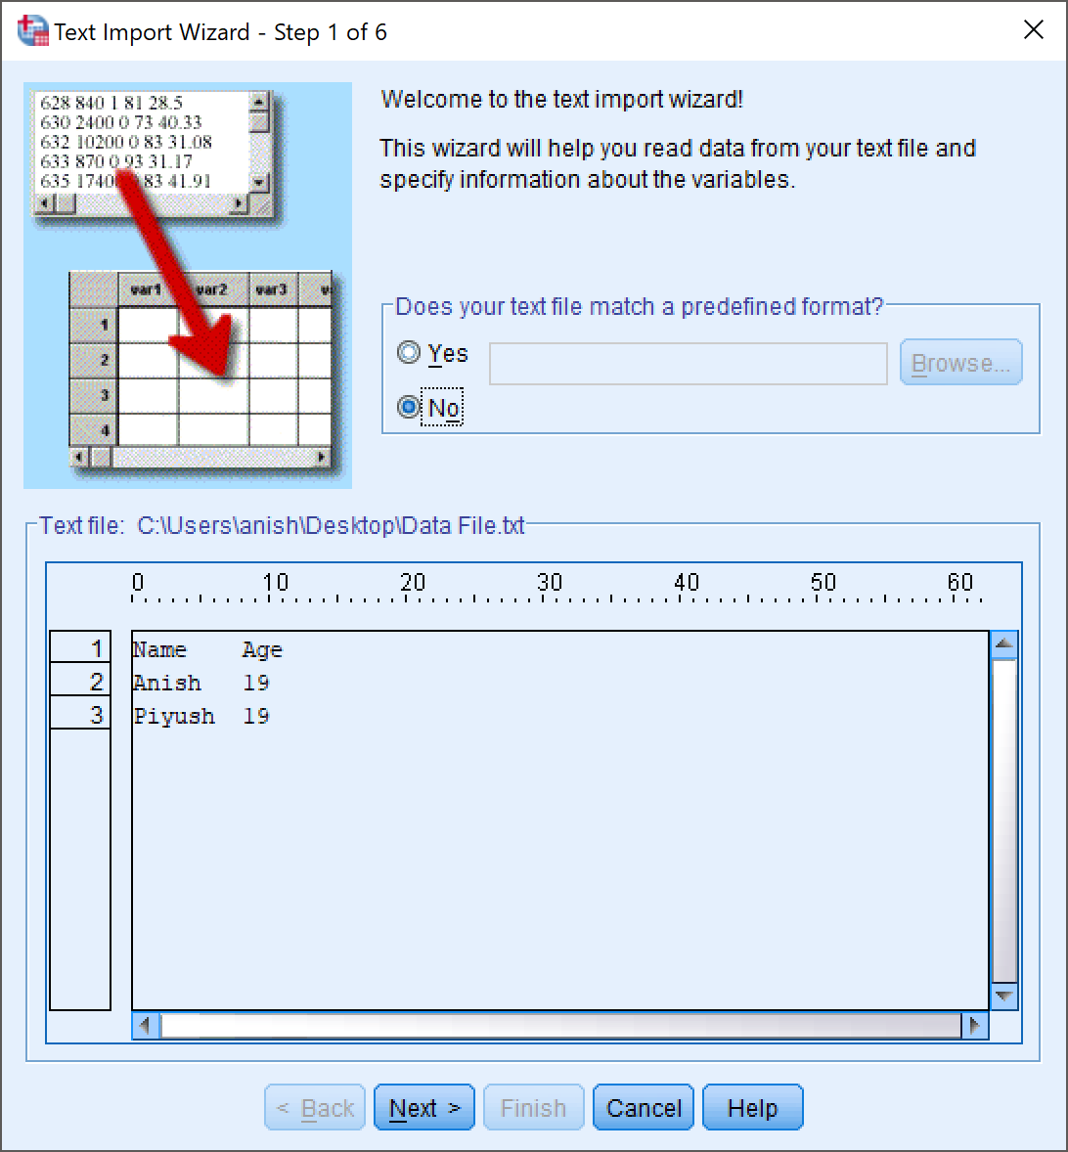

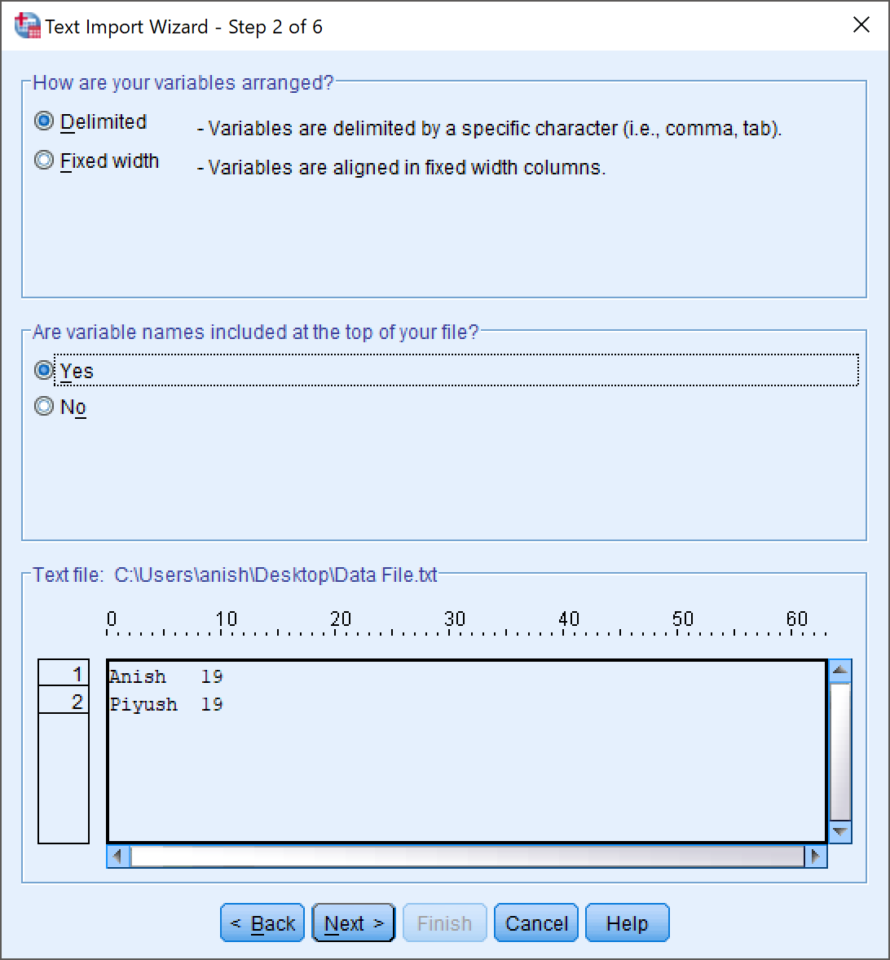

**Output:-**

File : Data File.sav

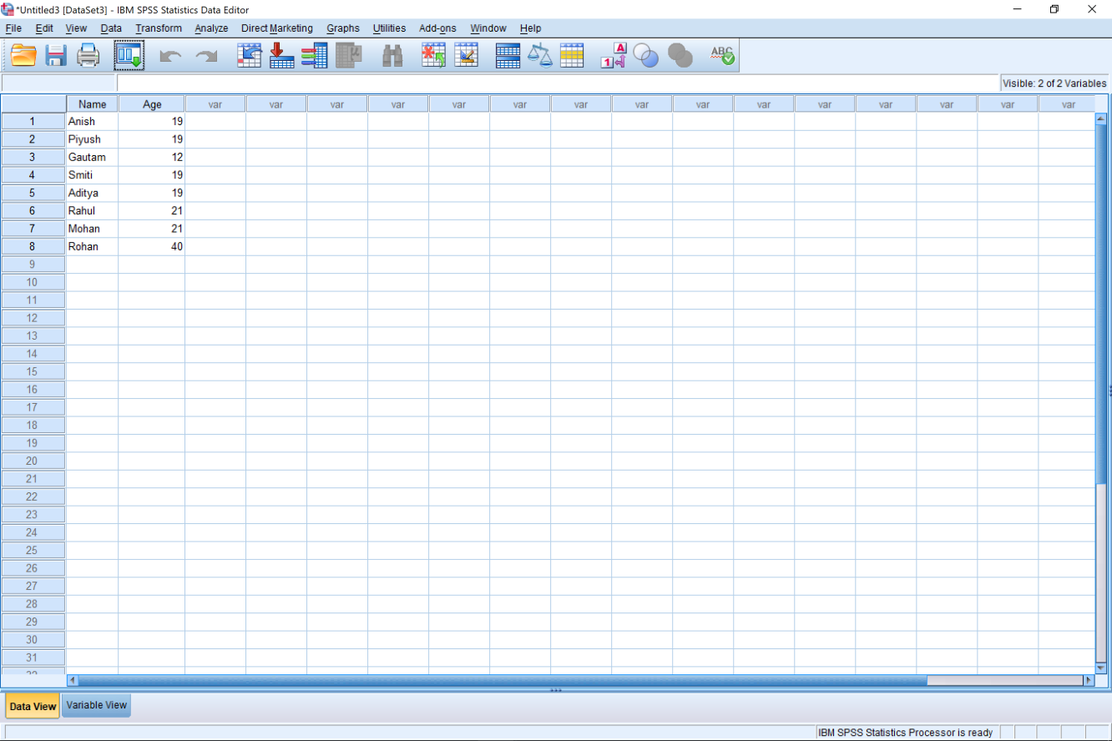

*Data View*

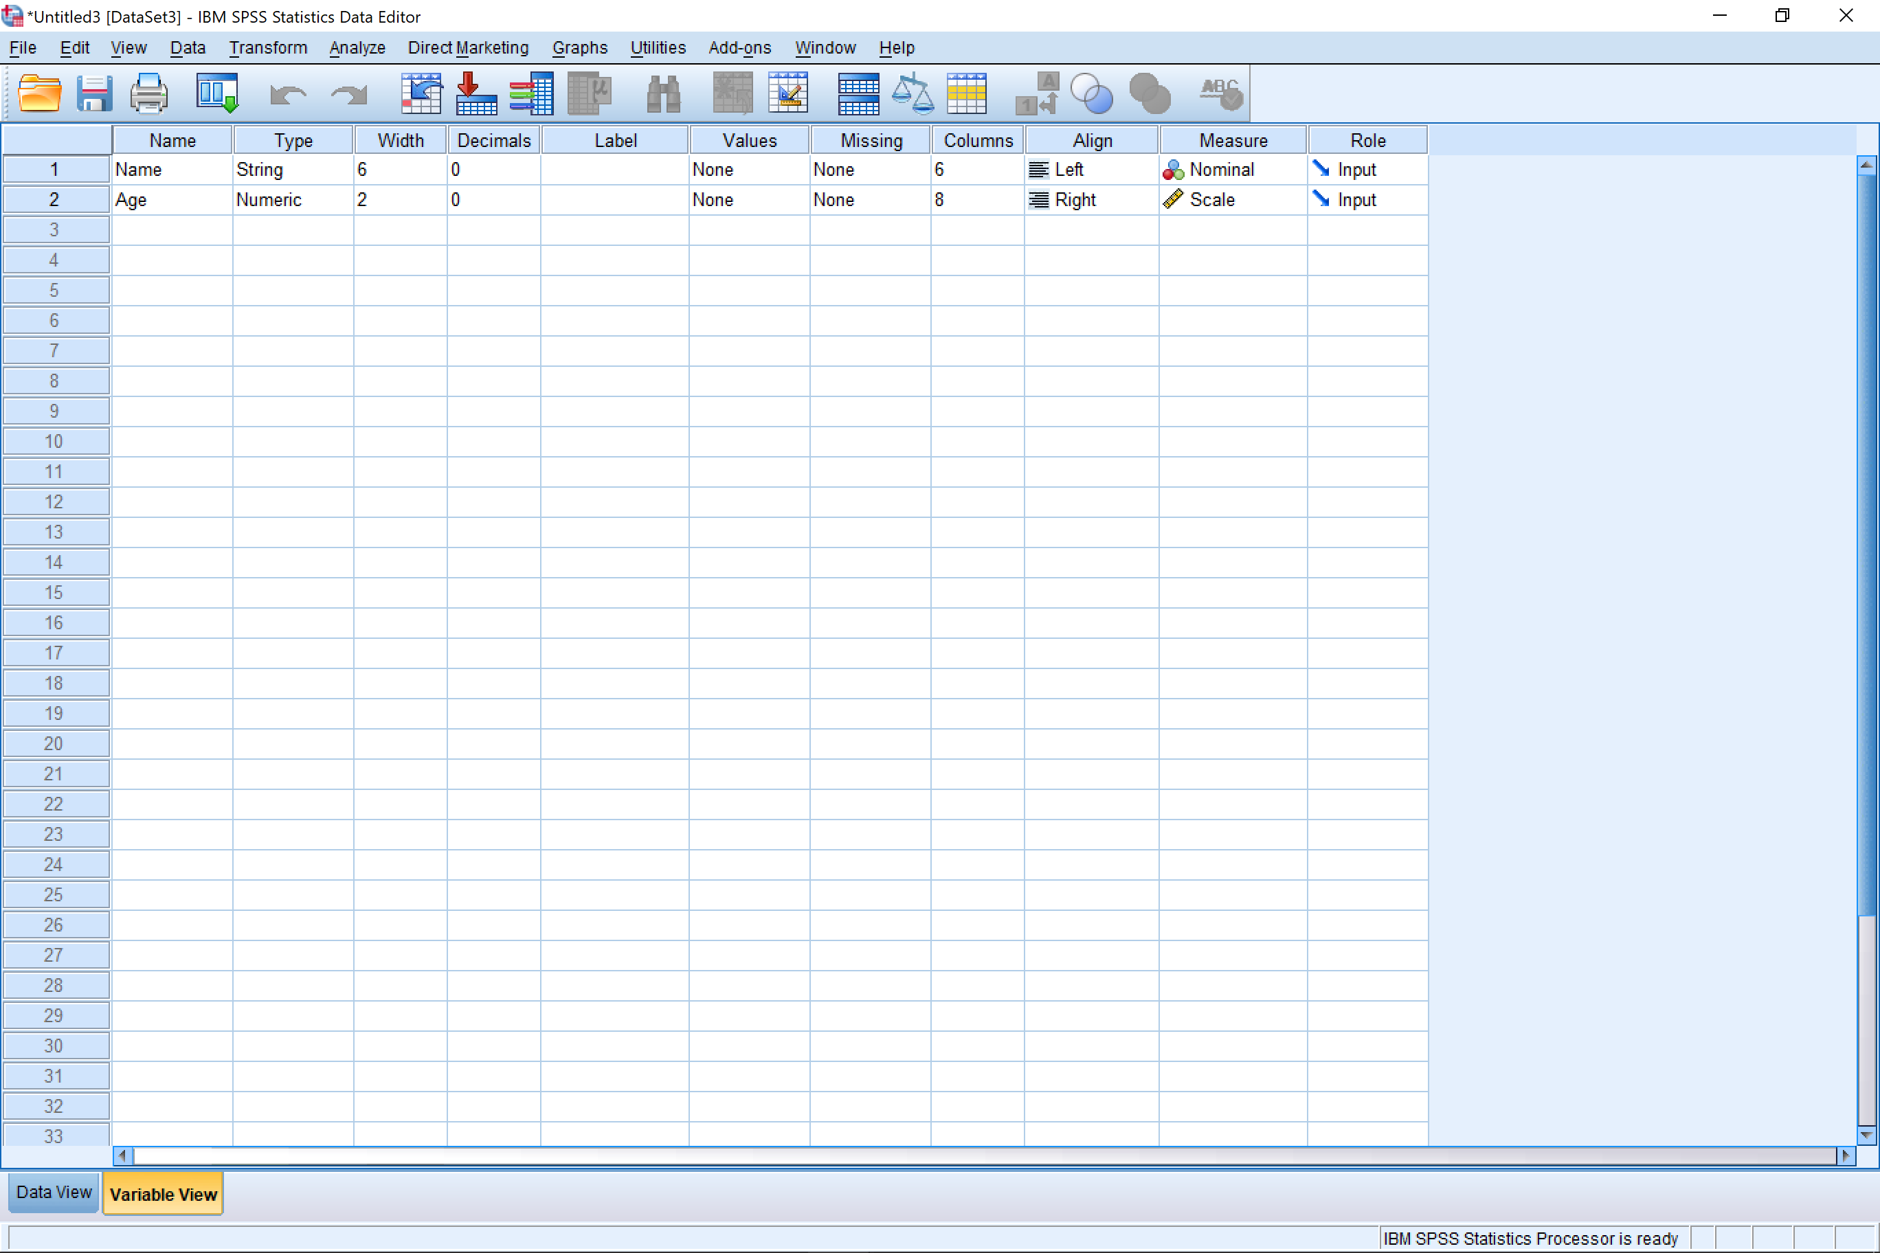

*Variable View*

# Conclusion

Any excel file (.xls .xlsx) or text file (.txt .rtxt) or any other format can be successfully transported to SPSS Data Editor Window and be saved as an SPSS Data Sheet document (.sav)

# Precautions

1. There should be proper spacing between variables in text file. The variables should either be comma separated or tab separated (recommended). The variables can also be separated by any other special symbol.
2. The file extensions should be taken into consideration very carefully during the conversion of any data sheet into another format or vica-versa.

Objective 2: Demonstrate the Selection of cases and Splitting of Tables, Merging of Tables with Cases and Variables

Inputs: HarryPotter.sav (Main File to be used for splitting), ToAdd_DataBase.sav (Extra Data Base to add variables into Main Data Base)

# Selection of Cases

1. Data -> Select Cases

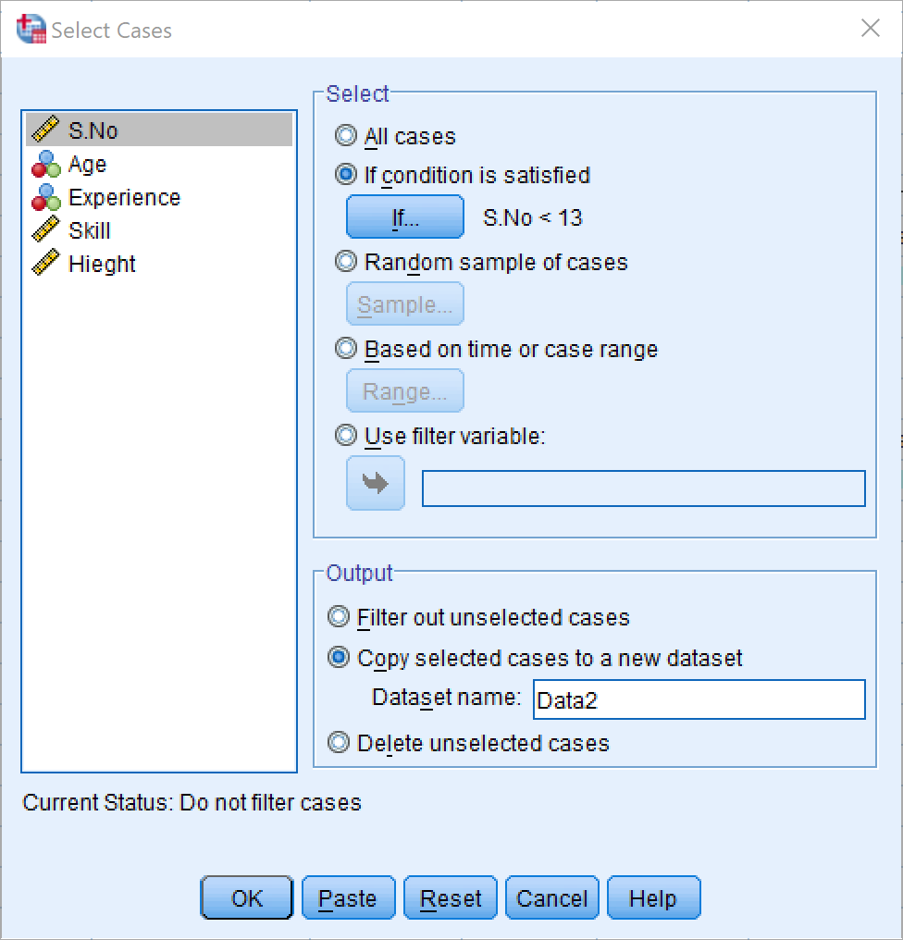

Then using the if condition we select how we want to divide the data into a smaller sub set.

**Output:-**

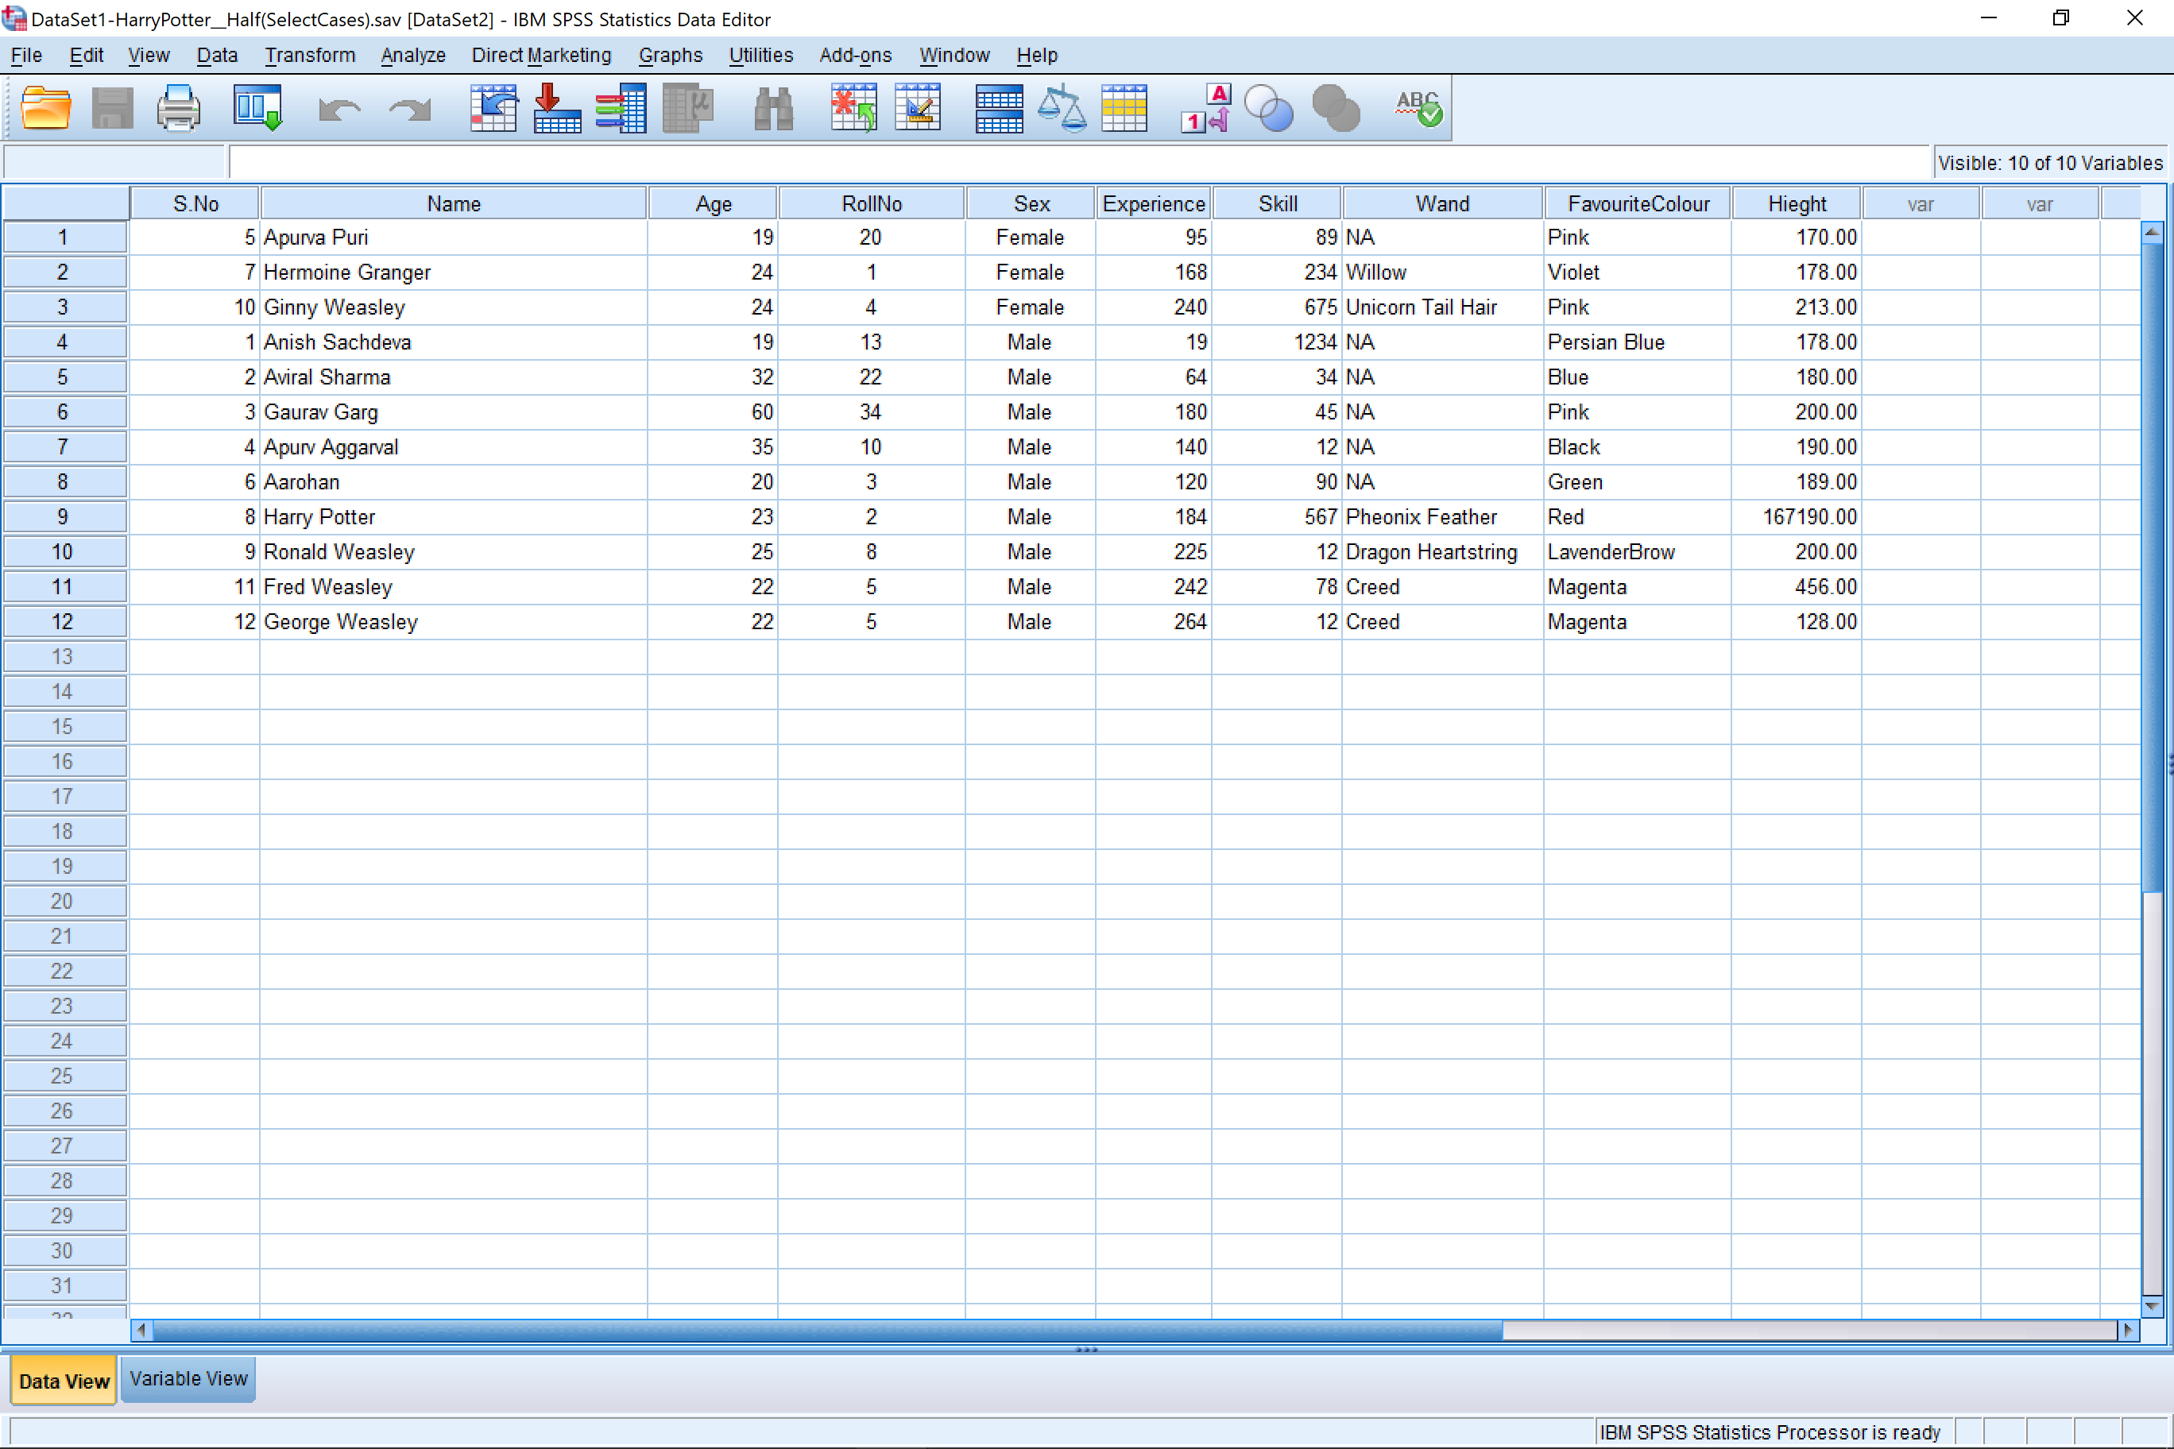

Selecting the cases for the second half of the table:-

1. Data -> Select Cases

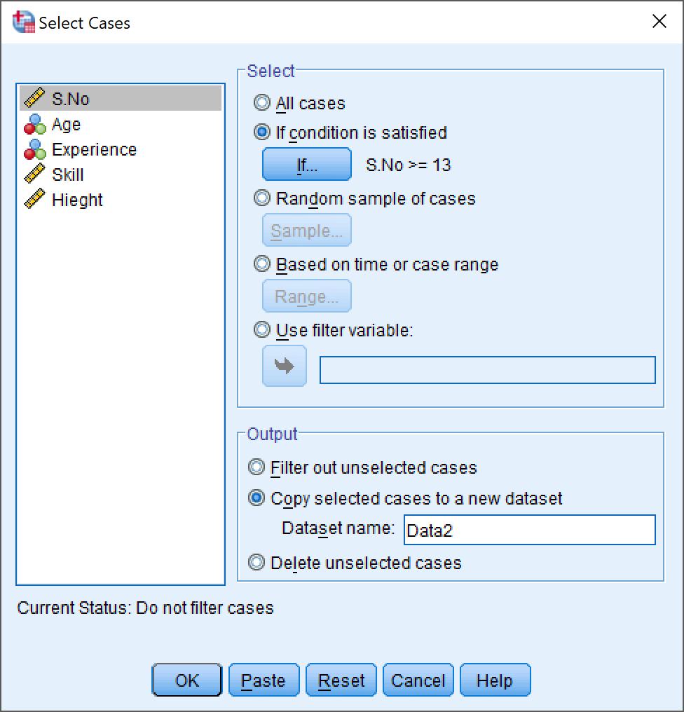

**Output:-**

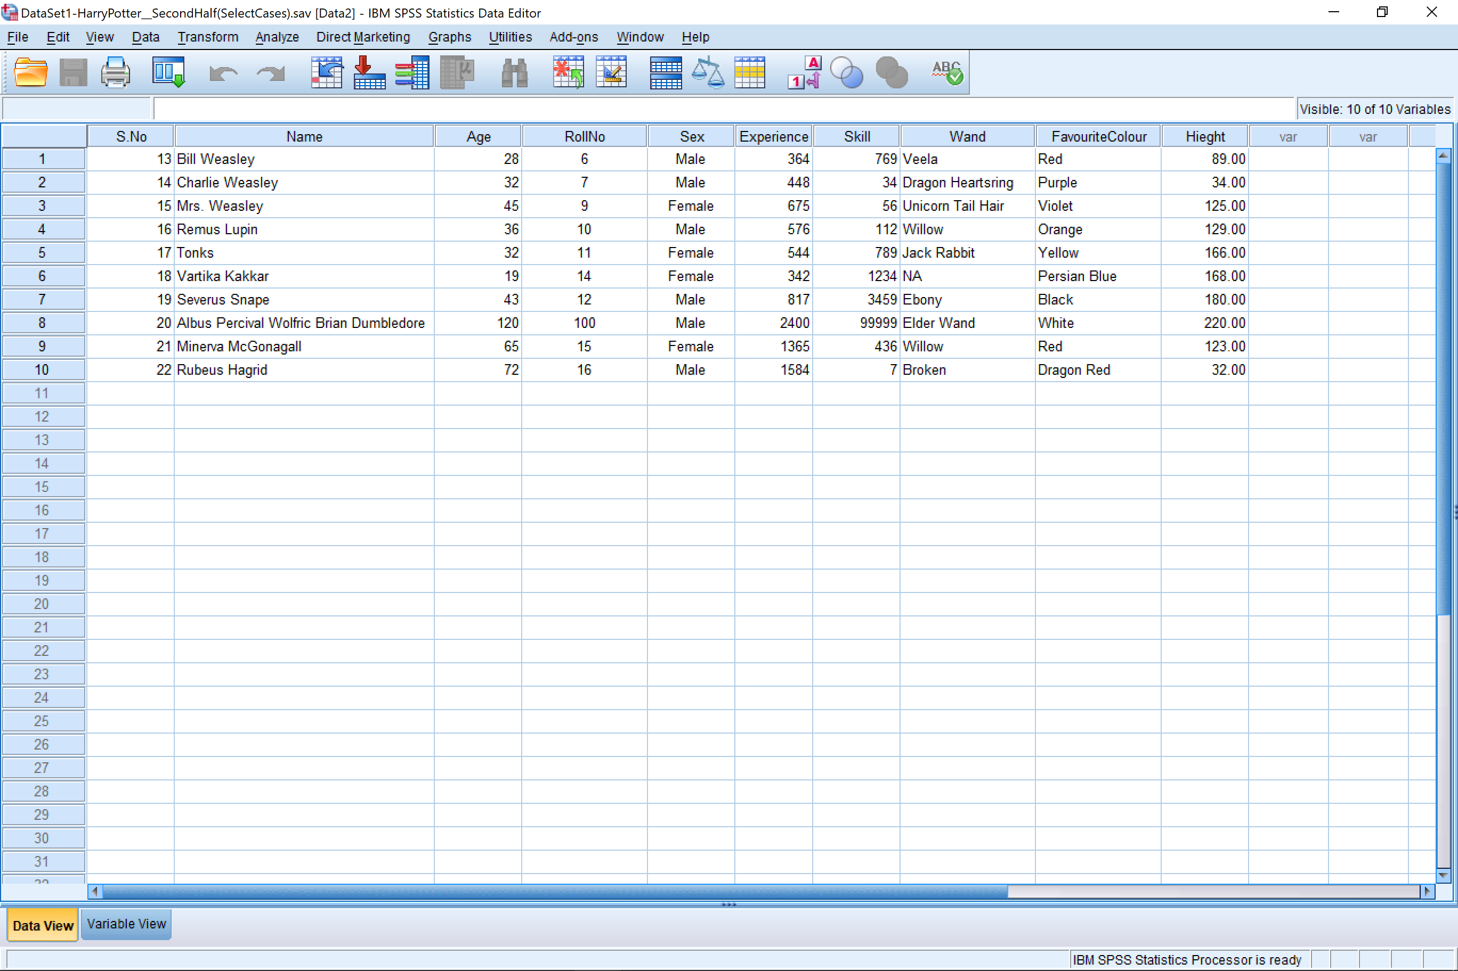

# Merge Files by Cases

**Commands:-**

1. Data -> Merge -> Add Cases

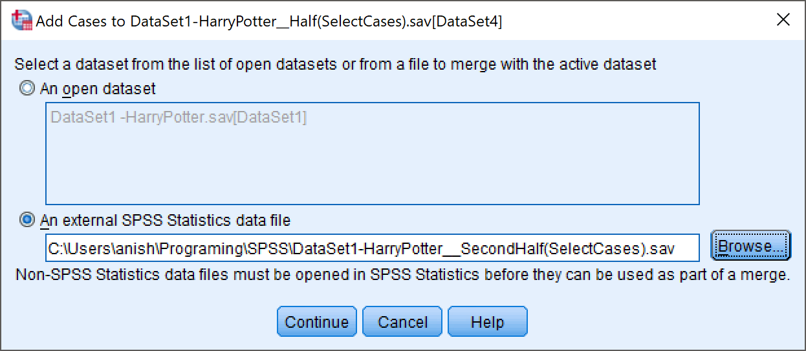

1. Pair similar Variable Names

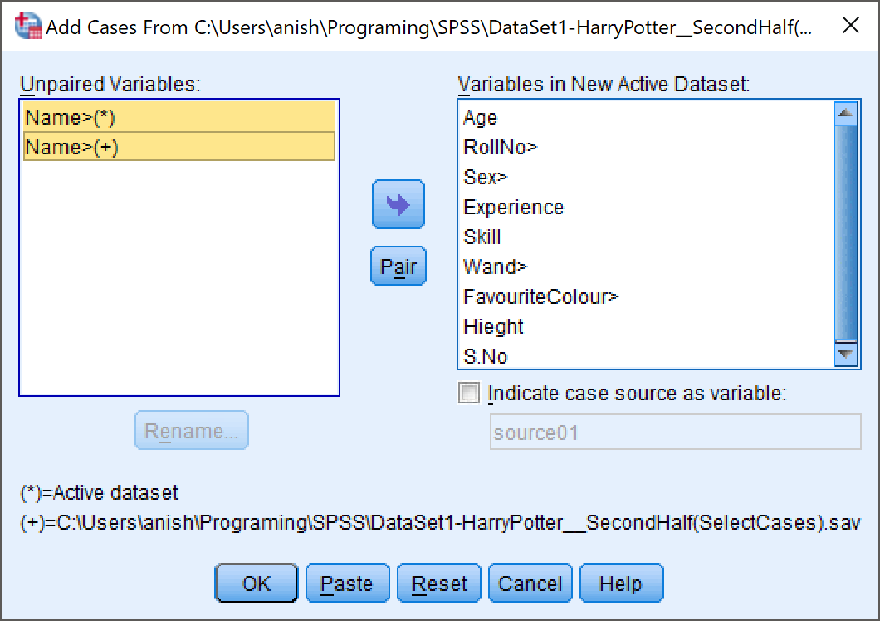

**Output:-**

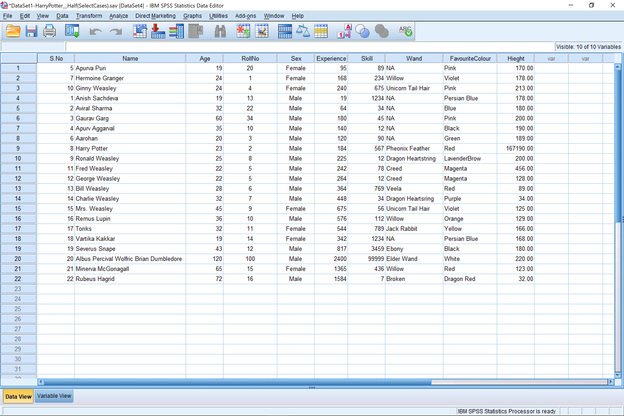

*All the Cases Have Been Merged*

# Merge Files By variables

**Commands:-**

1. Data -> Merge Files -> Add Variables

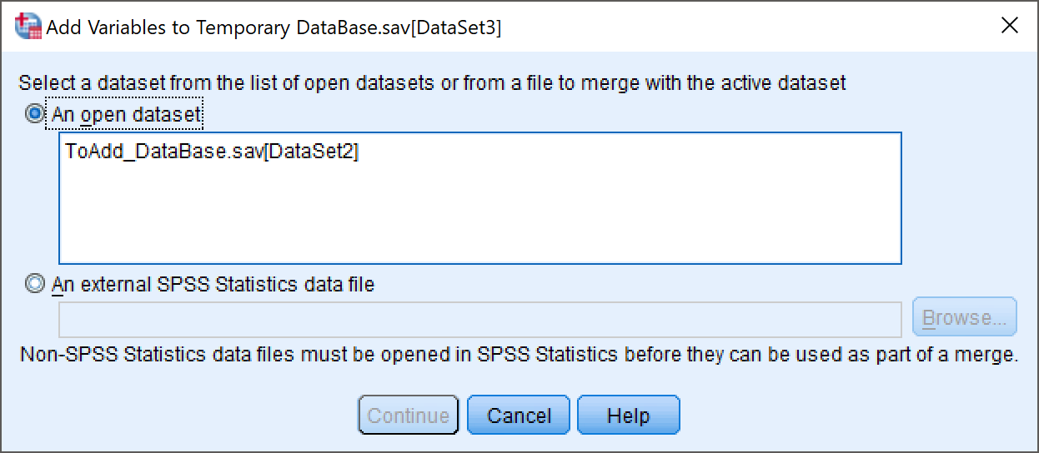

1. Select the Variables you wish to include or exclude

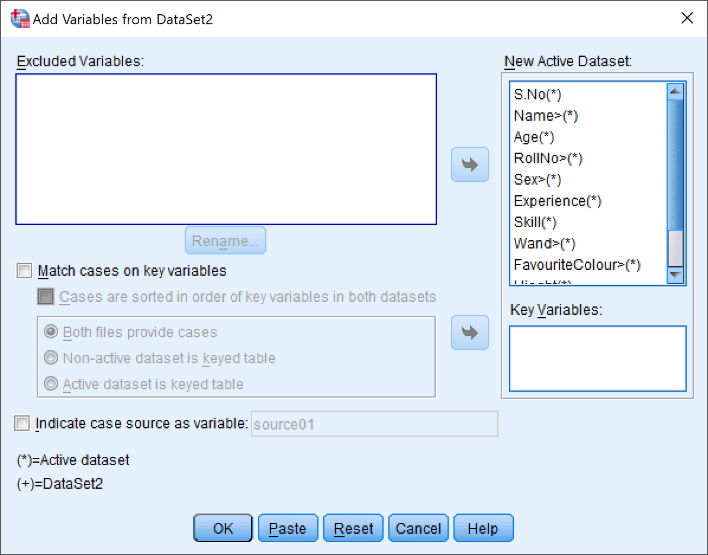

**Output:-**

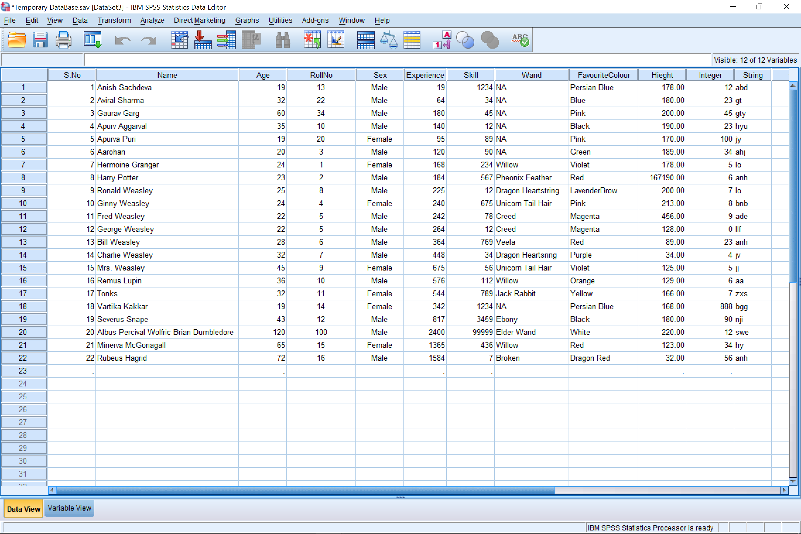

Here, 2 new Variables have been added to the data set. i.e. ‘Integer’ and ‘String’.

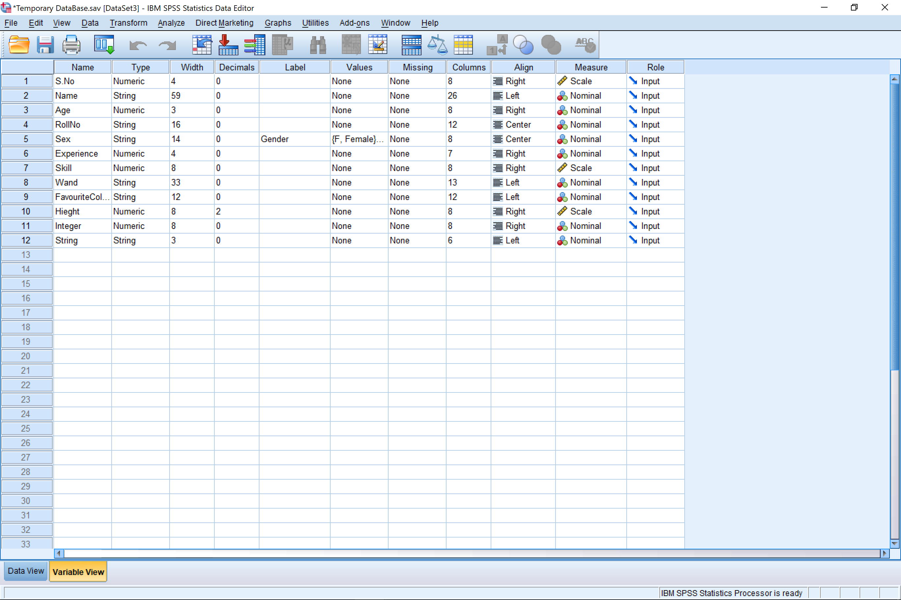

*Variable View*

# Conclusion

We conclude that in SPSS Statistics Software you can easily select a number of cases from the data and then create a smaller sub set of that table henceforth. This is particularly useful when we need to view a specific portion of the table that adheres to certain conditions.

We also conclude that we can easily add the cases from a data base to another open data base, by using the Merge -> Add Cases property. This is very useful when we wish to expand our data o the basis of pre-existing data base.

We conclude that we can add variables from another data base into the data base that is currently open. This is especially useful when we wish to add pre-existing properties to our data base.

# Precautions

1. While adding variables to the file make sure that both the files were sorted in the same order. (Ascending or Descending)
2. While merging cases, make sure that both the unpaired variables are properly named or paired and then add the cases into the existing data base.
3. The conditional statement which will decide the cases that will be selected should be formed carefully.

Objective 3: Demonstrate the Pictoral Representation of Data

**Inputs :** car_sales.sav

# Procedure

1. Graphs -> Chart Builder

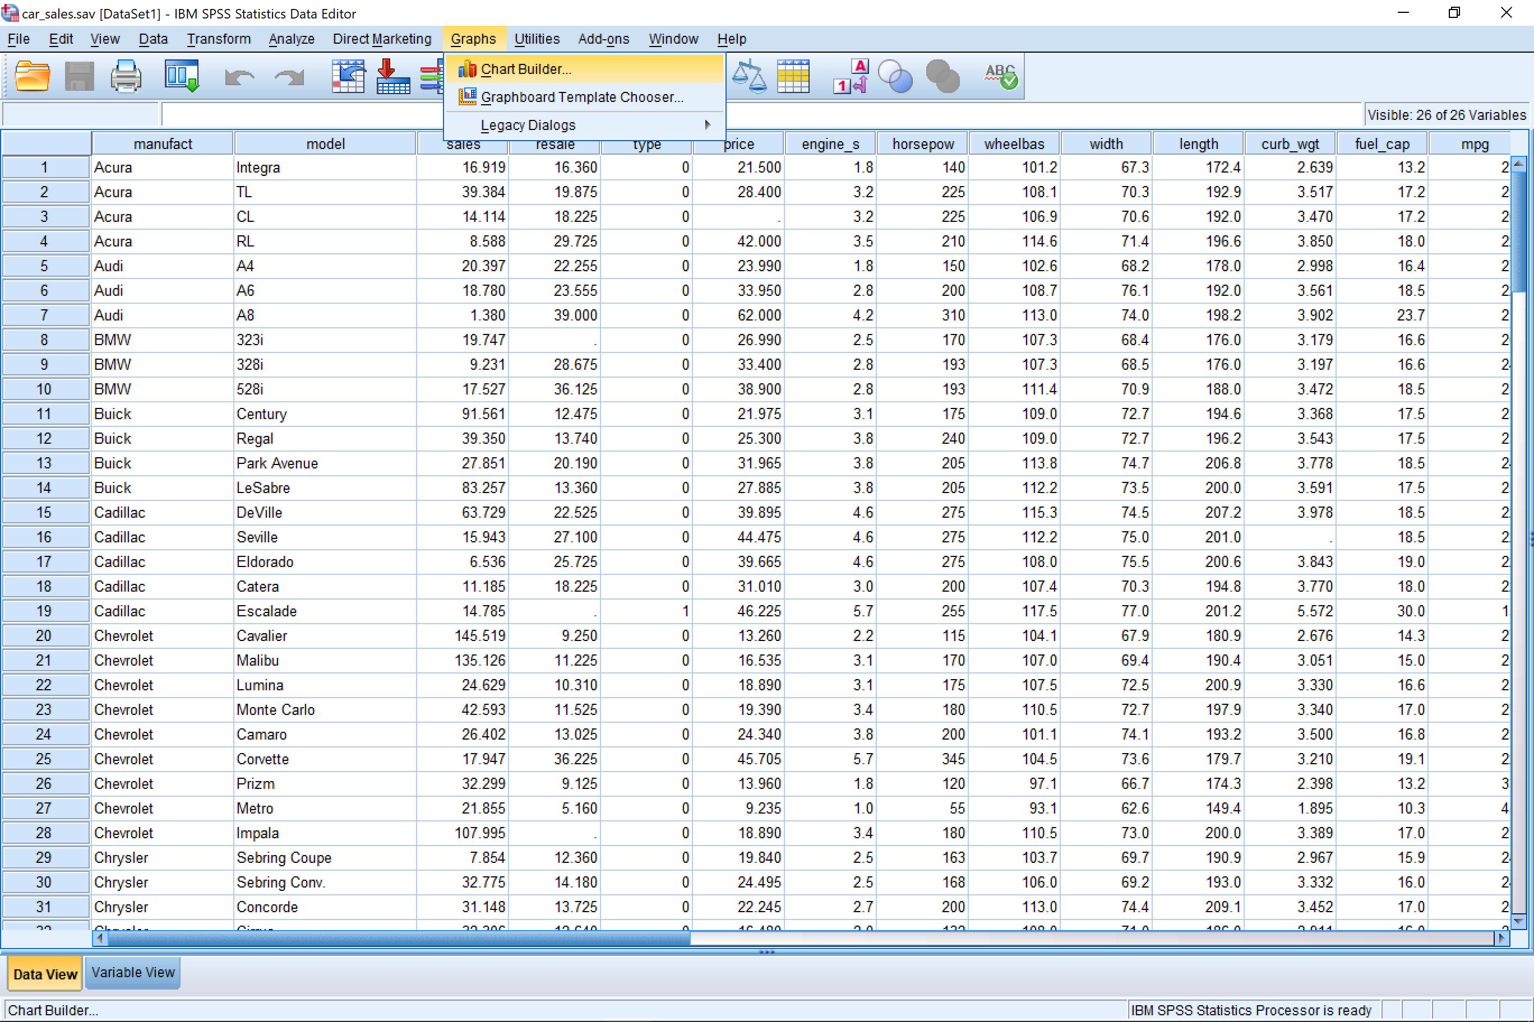

1. Select The Type of Graph you want from the chart preview

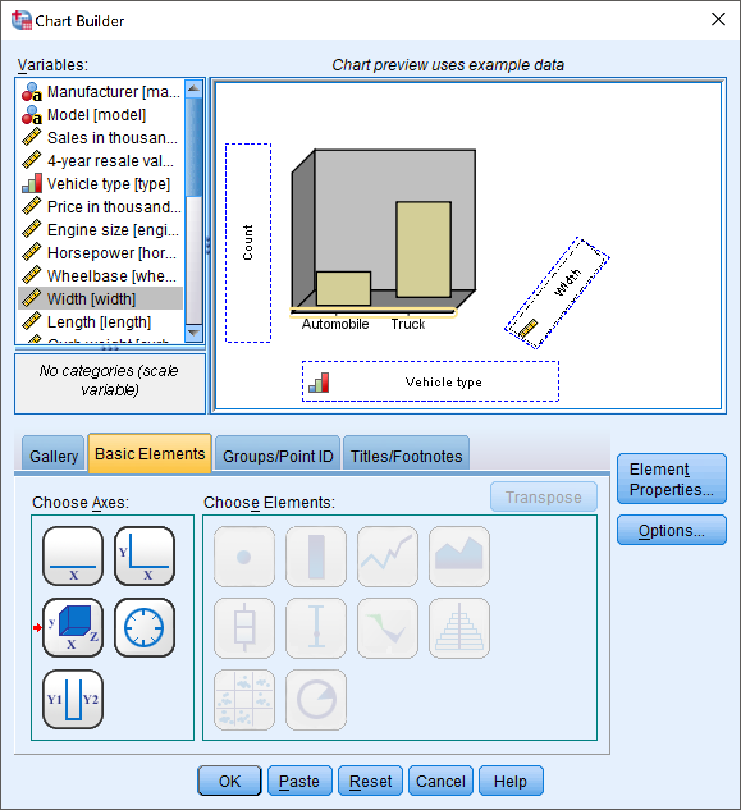

1. Now you can select and drag the variables you want to the chart.
2. Now the graph will be opened in the output window.

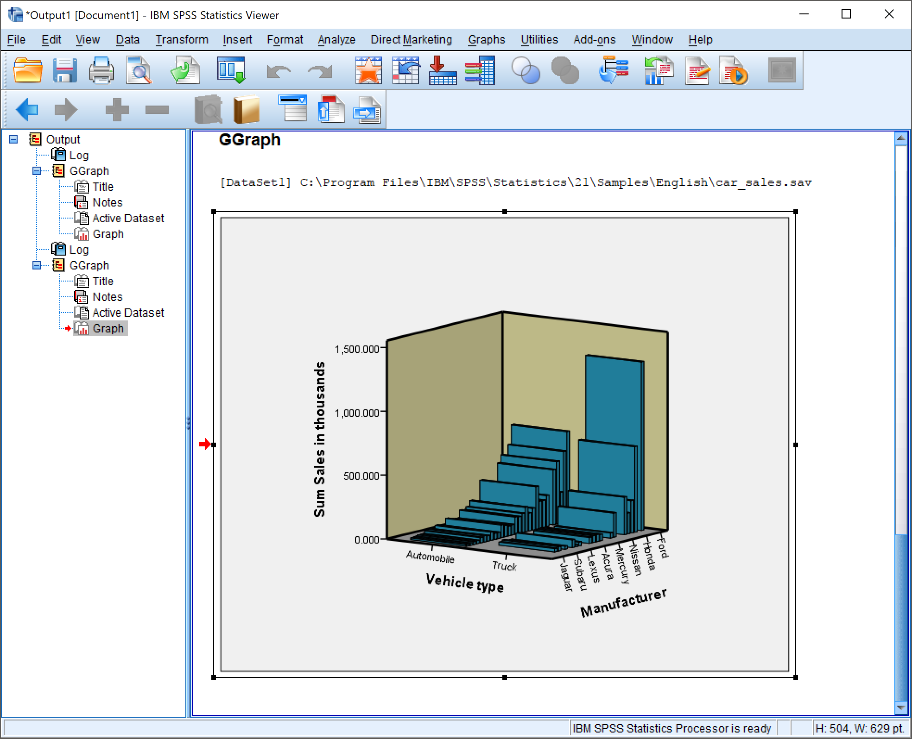

# Editing the Graph

You can further edit this graph using the chart editor (double click on the graph).

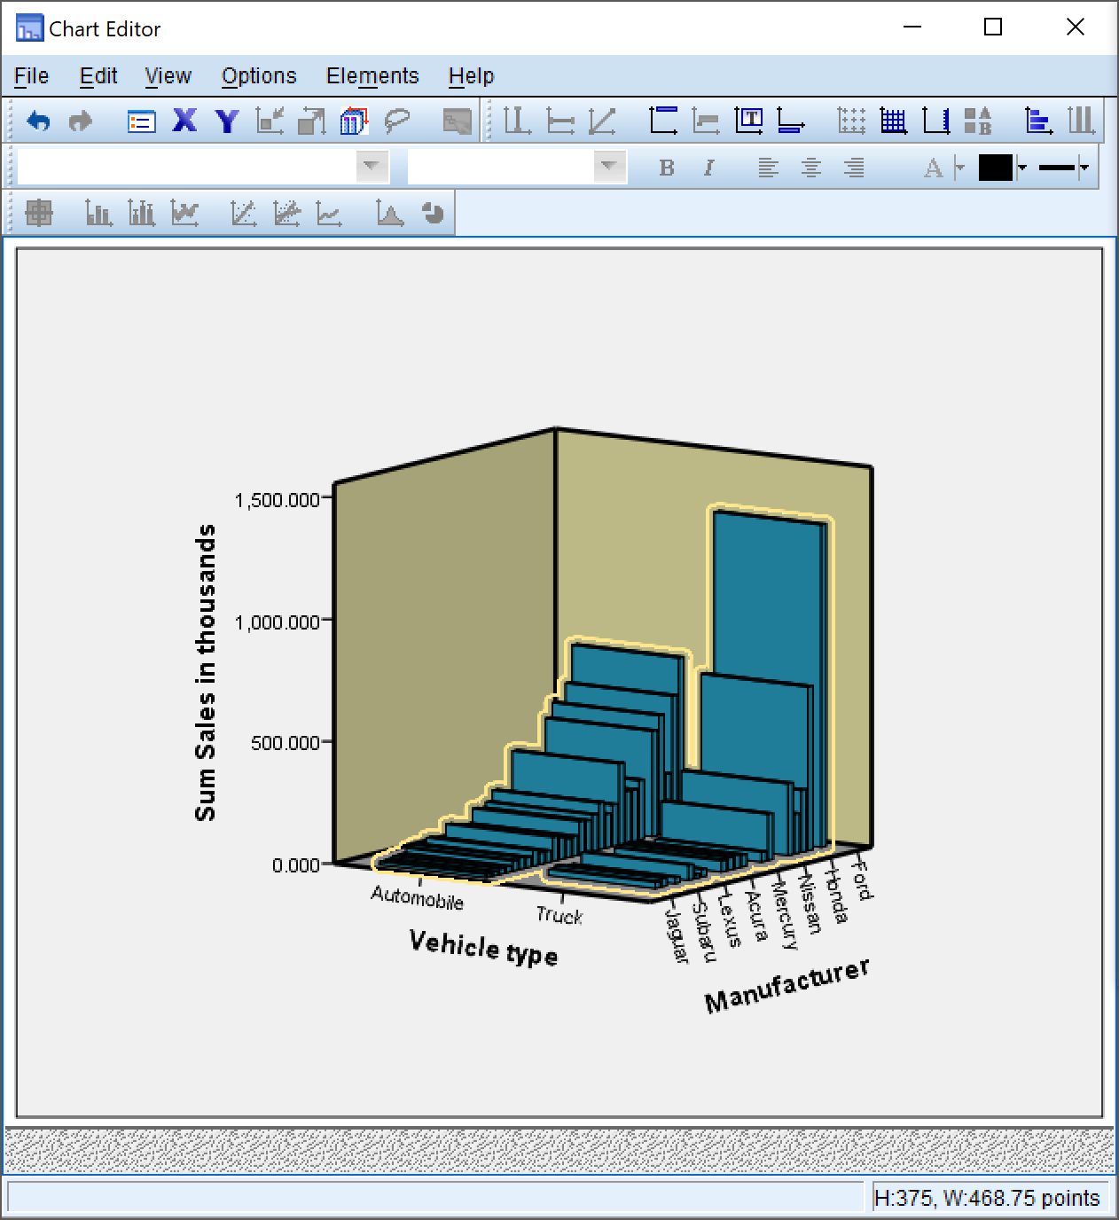

We can change the graph properties using the properties pane on the chart editor.

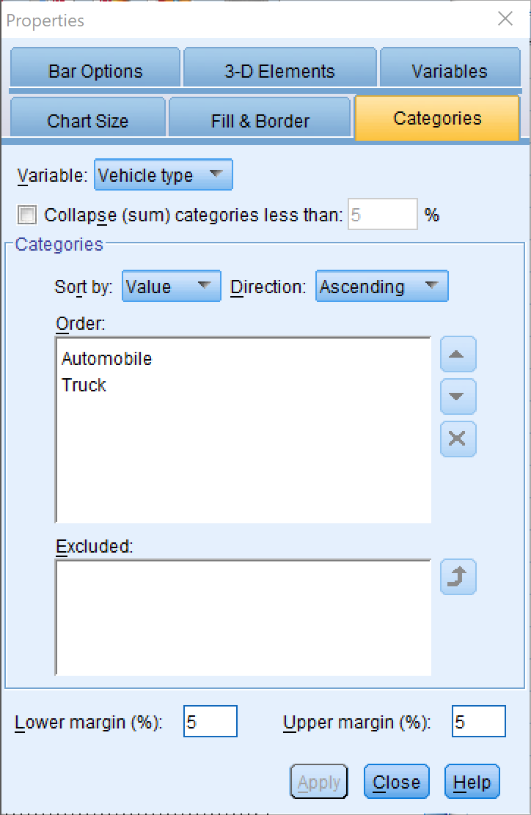

# Pie Chart

We can also create using the chart builder a pie Chart

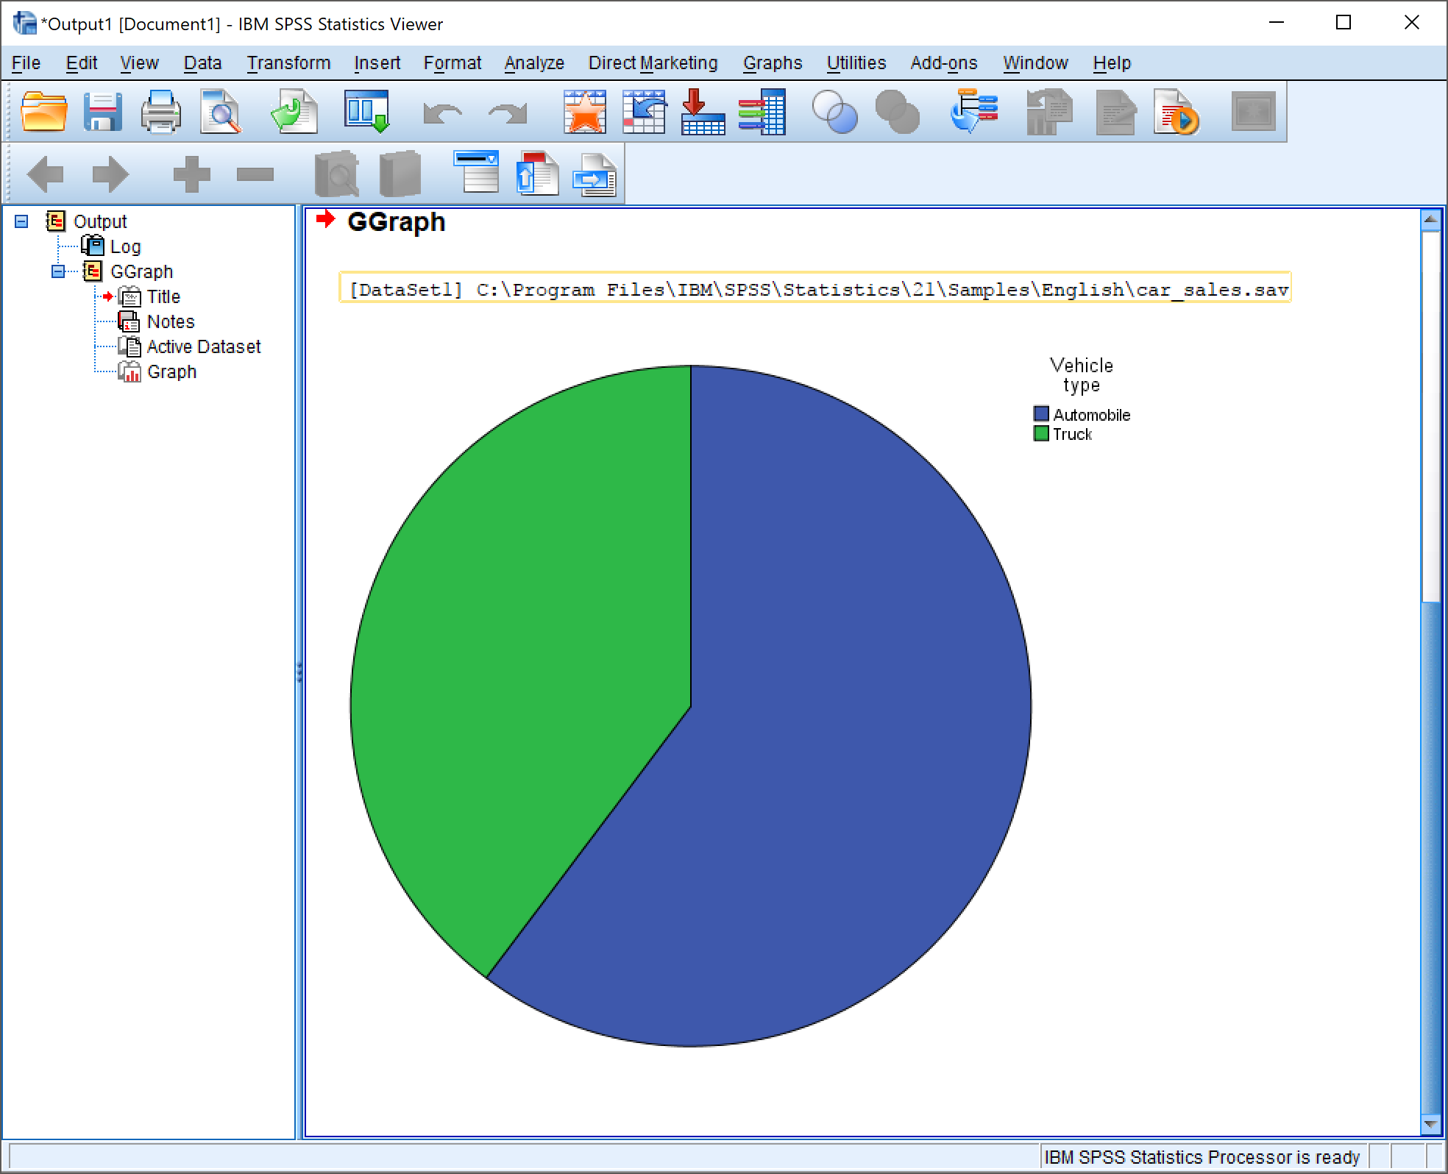

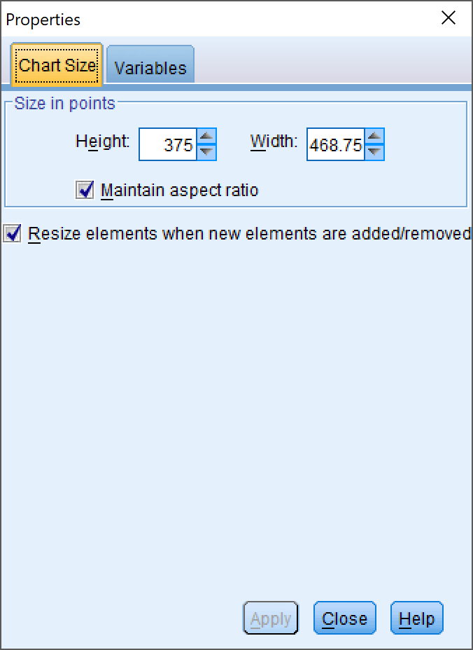We can edit the pie chart using the chart editor and properties pane:-

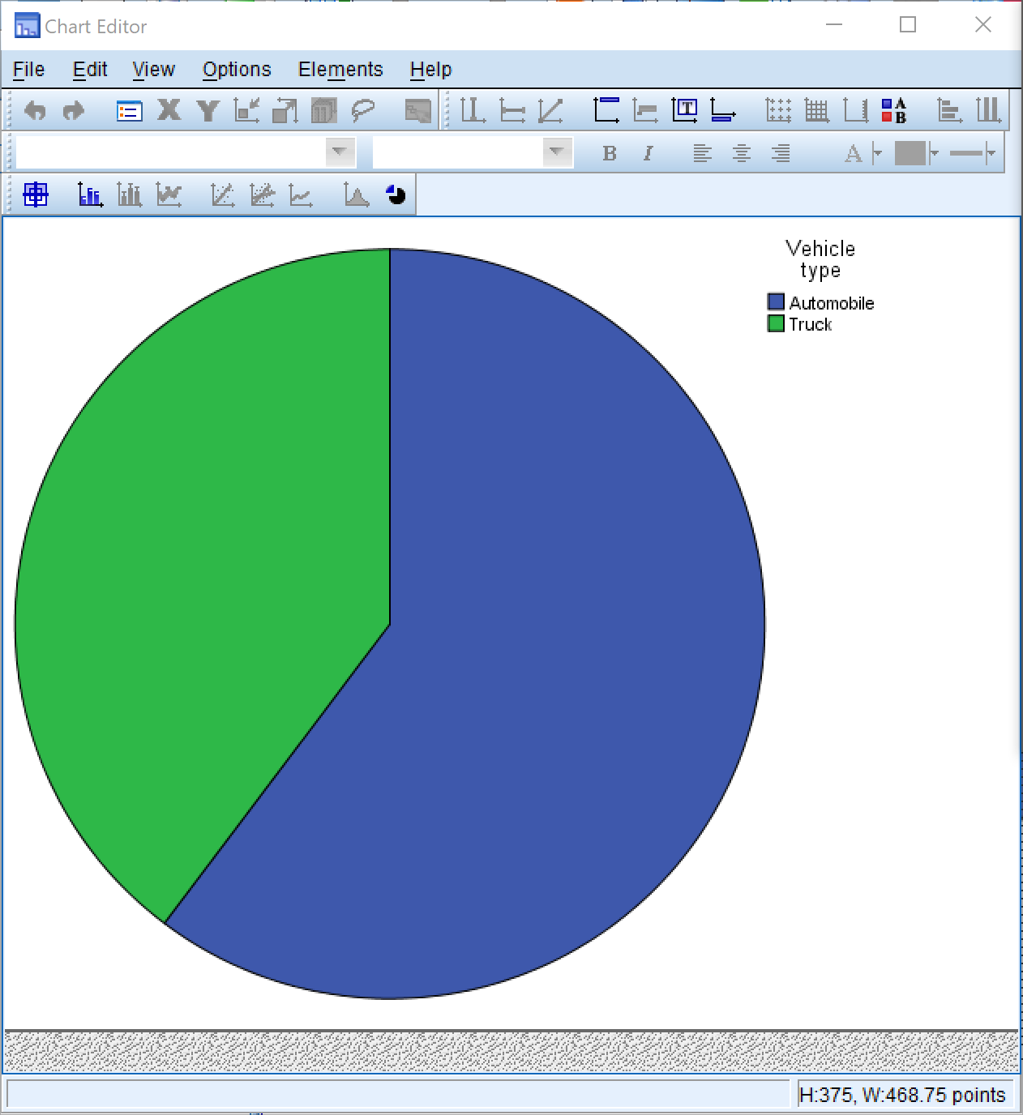

# Output (After Editing)

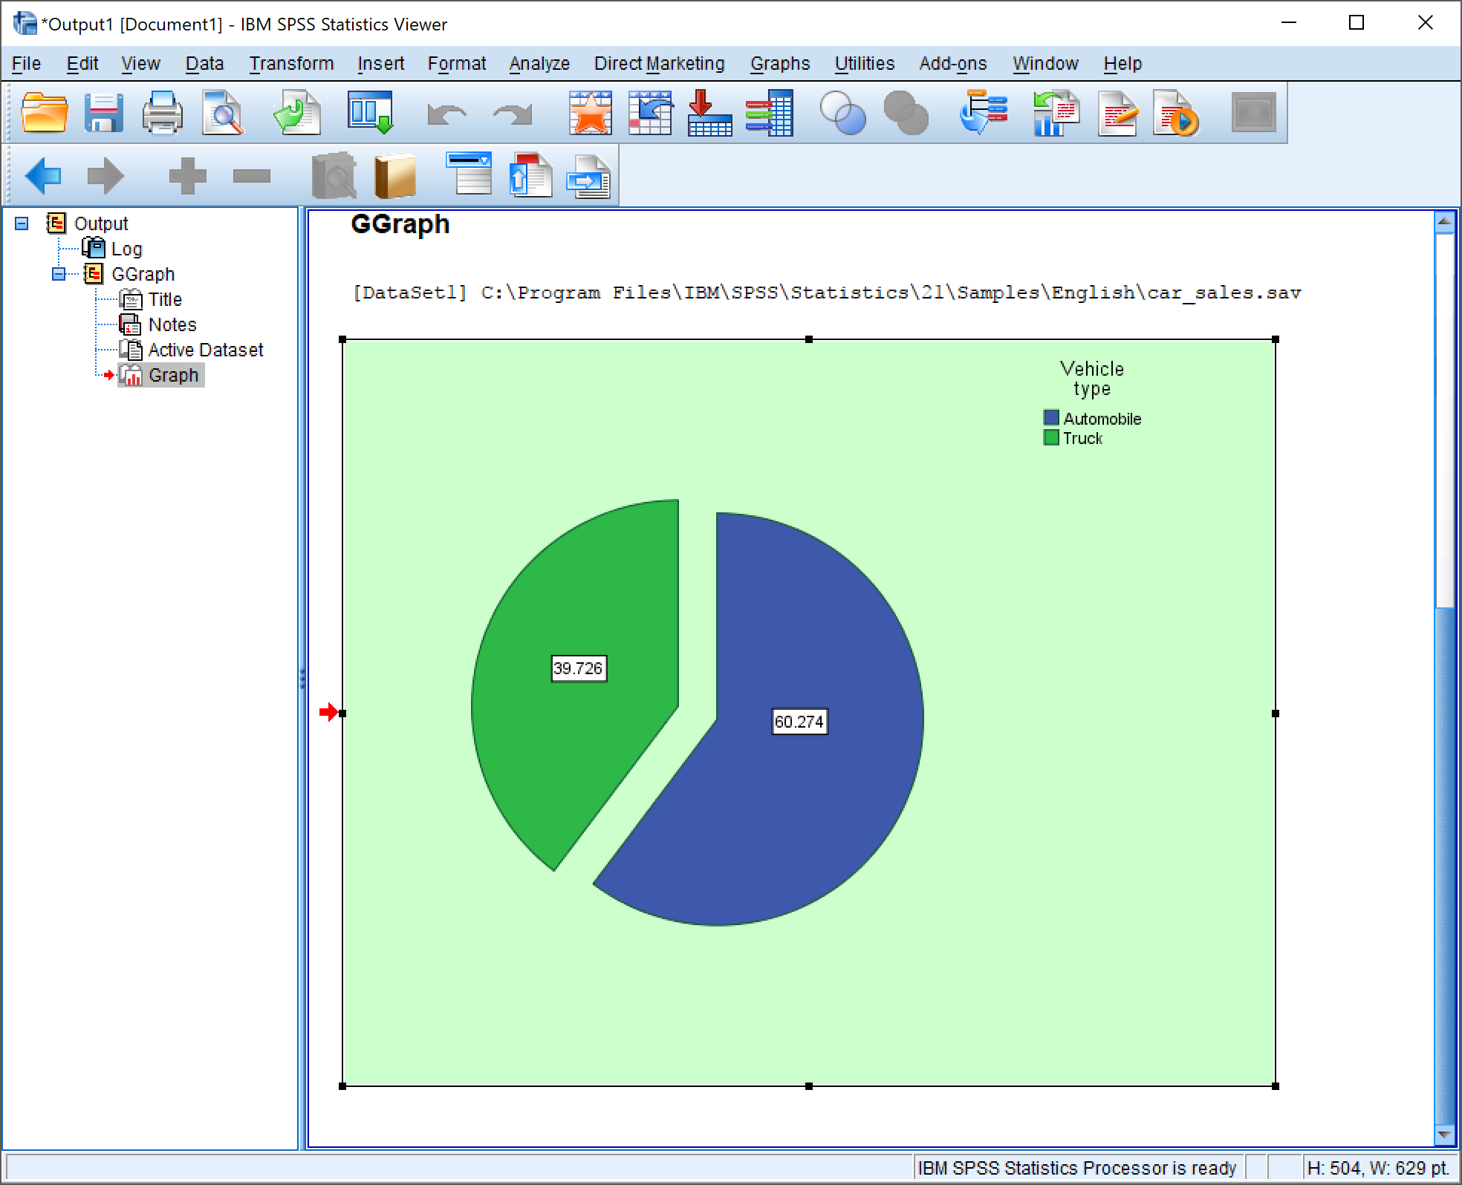

# Conclusion

We conclude that for any set of data we can easily represent it with the help of graphs. We also conclude that graphs can be easily modified and edited to better pictorially represent data using SPSS Statistics Software.

# Precautions

1. The graph type should be chosen carefully which best represent our given data.
2. The variables being assigned to any axis should be chosen carefully, and their scale should be taken into account.
3. Graph labels, headings and footers should be chosen appropriately.

Objective 4: Descriptive Statistics

**Inputs:** HarryPotter.sav

# Procedure

1. Analyze -> Descriptive Statistics -> Frequencies

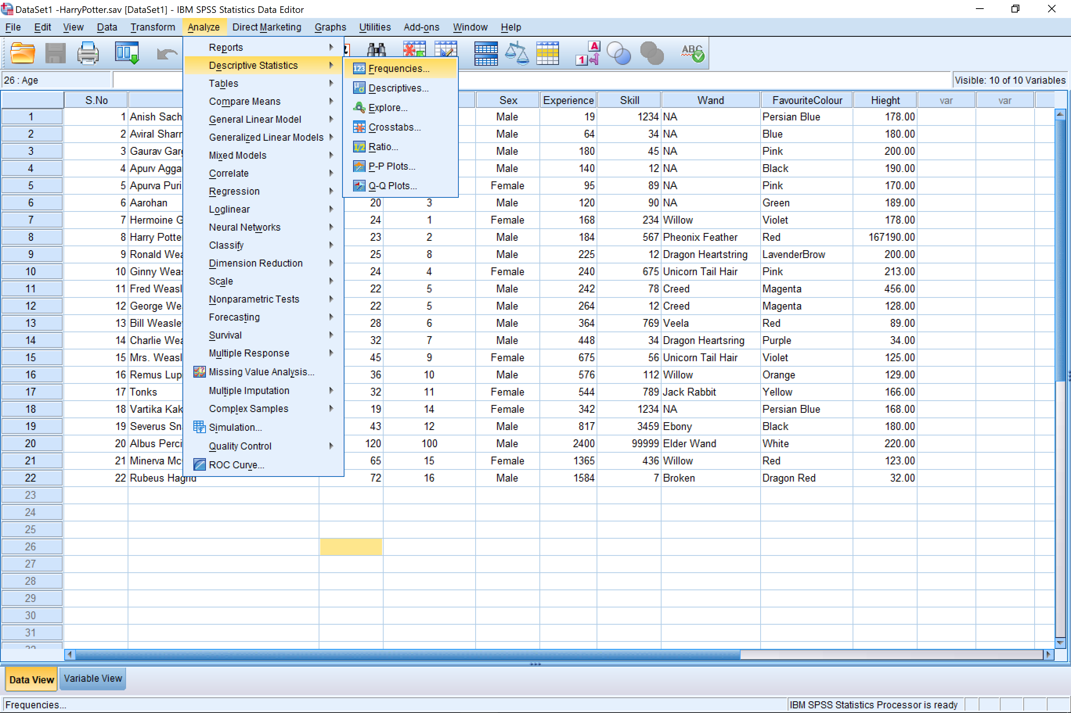

1. Add the variables you wish to use to the variables column.

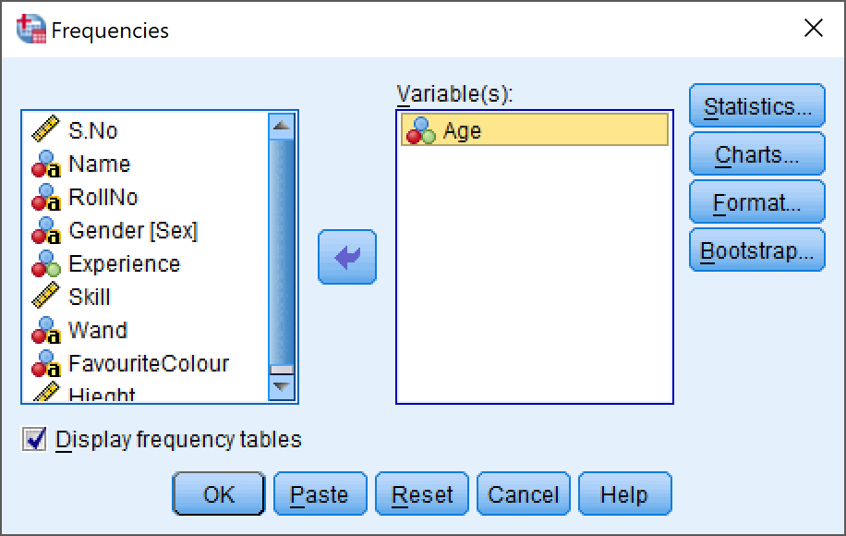

1. Then click on the ‘Statistics’ button to further select the data distribution properties, central Tendency, dispersion etc.

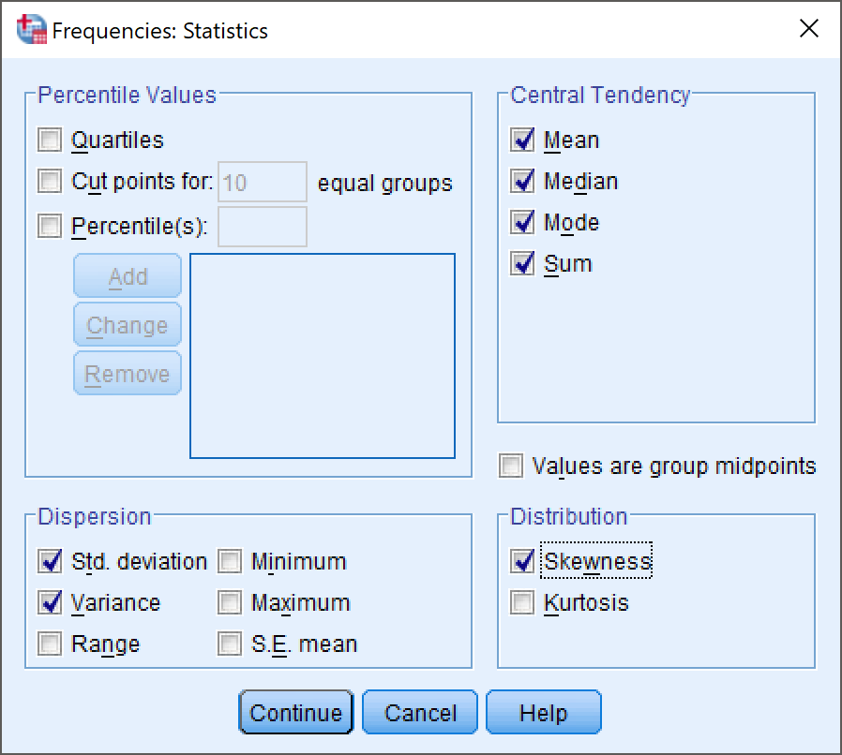

1. Then click on continue to receive the result of your descriptive statistics

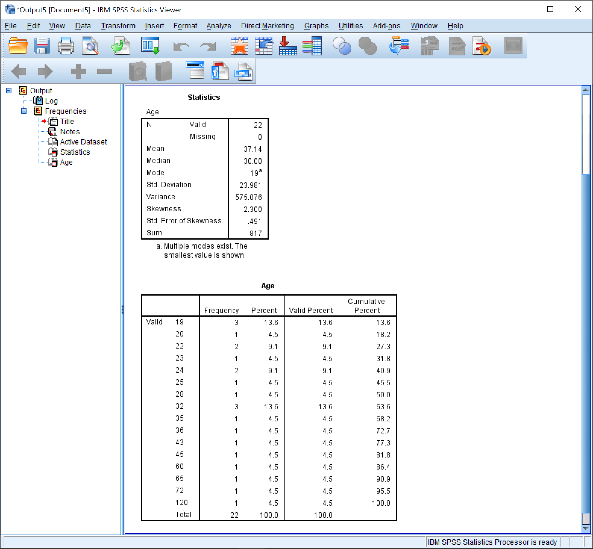

*Age Result*

The same can also be done with multiple variables:-

# Multiple Variables

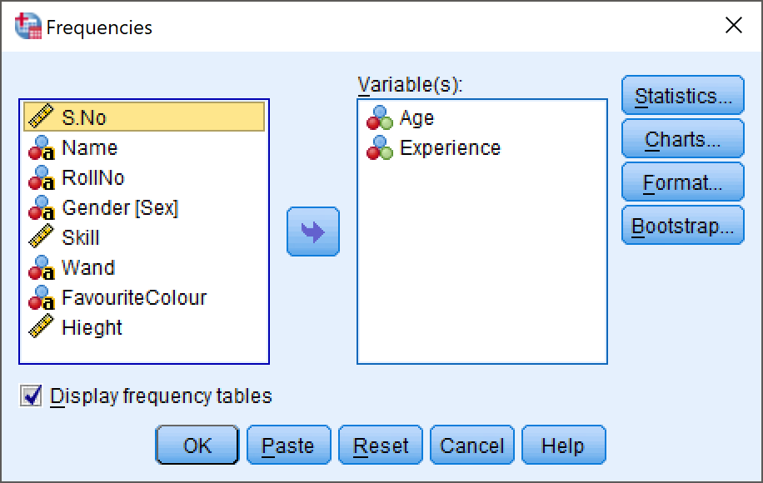

# Results

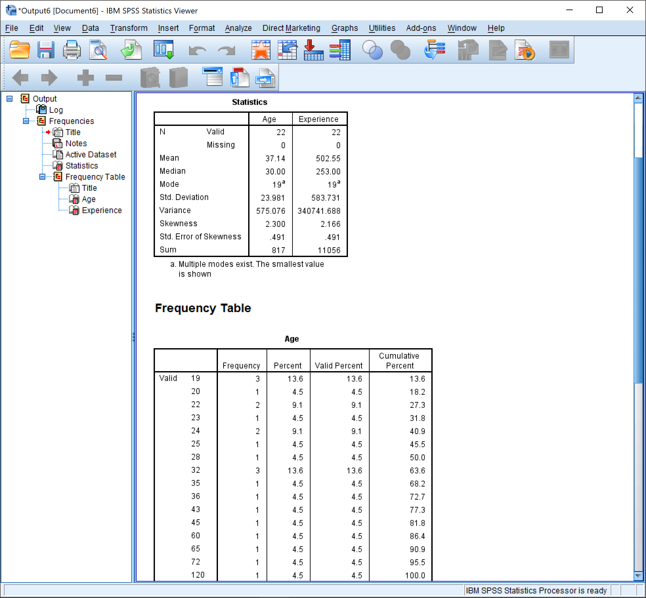

*Page 1*

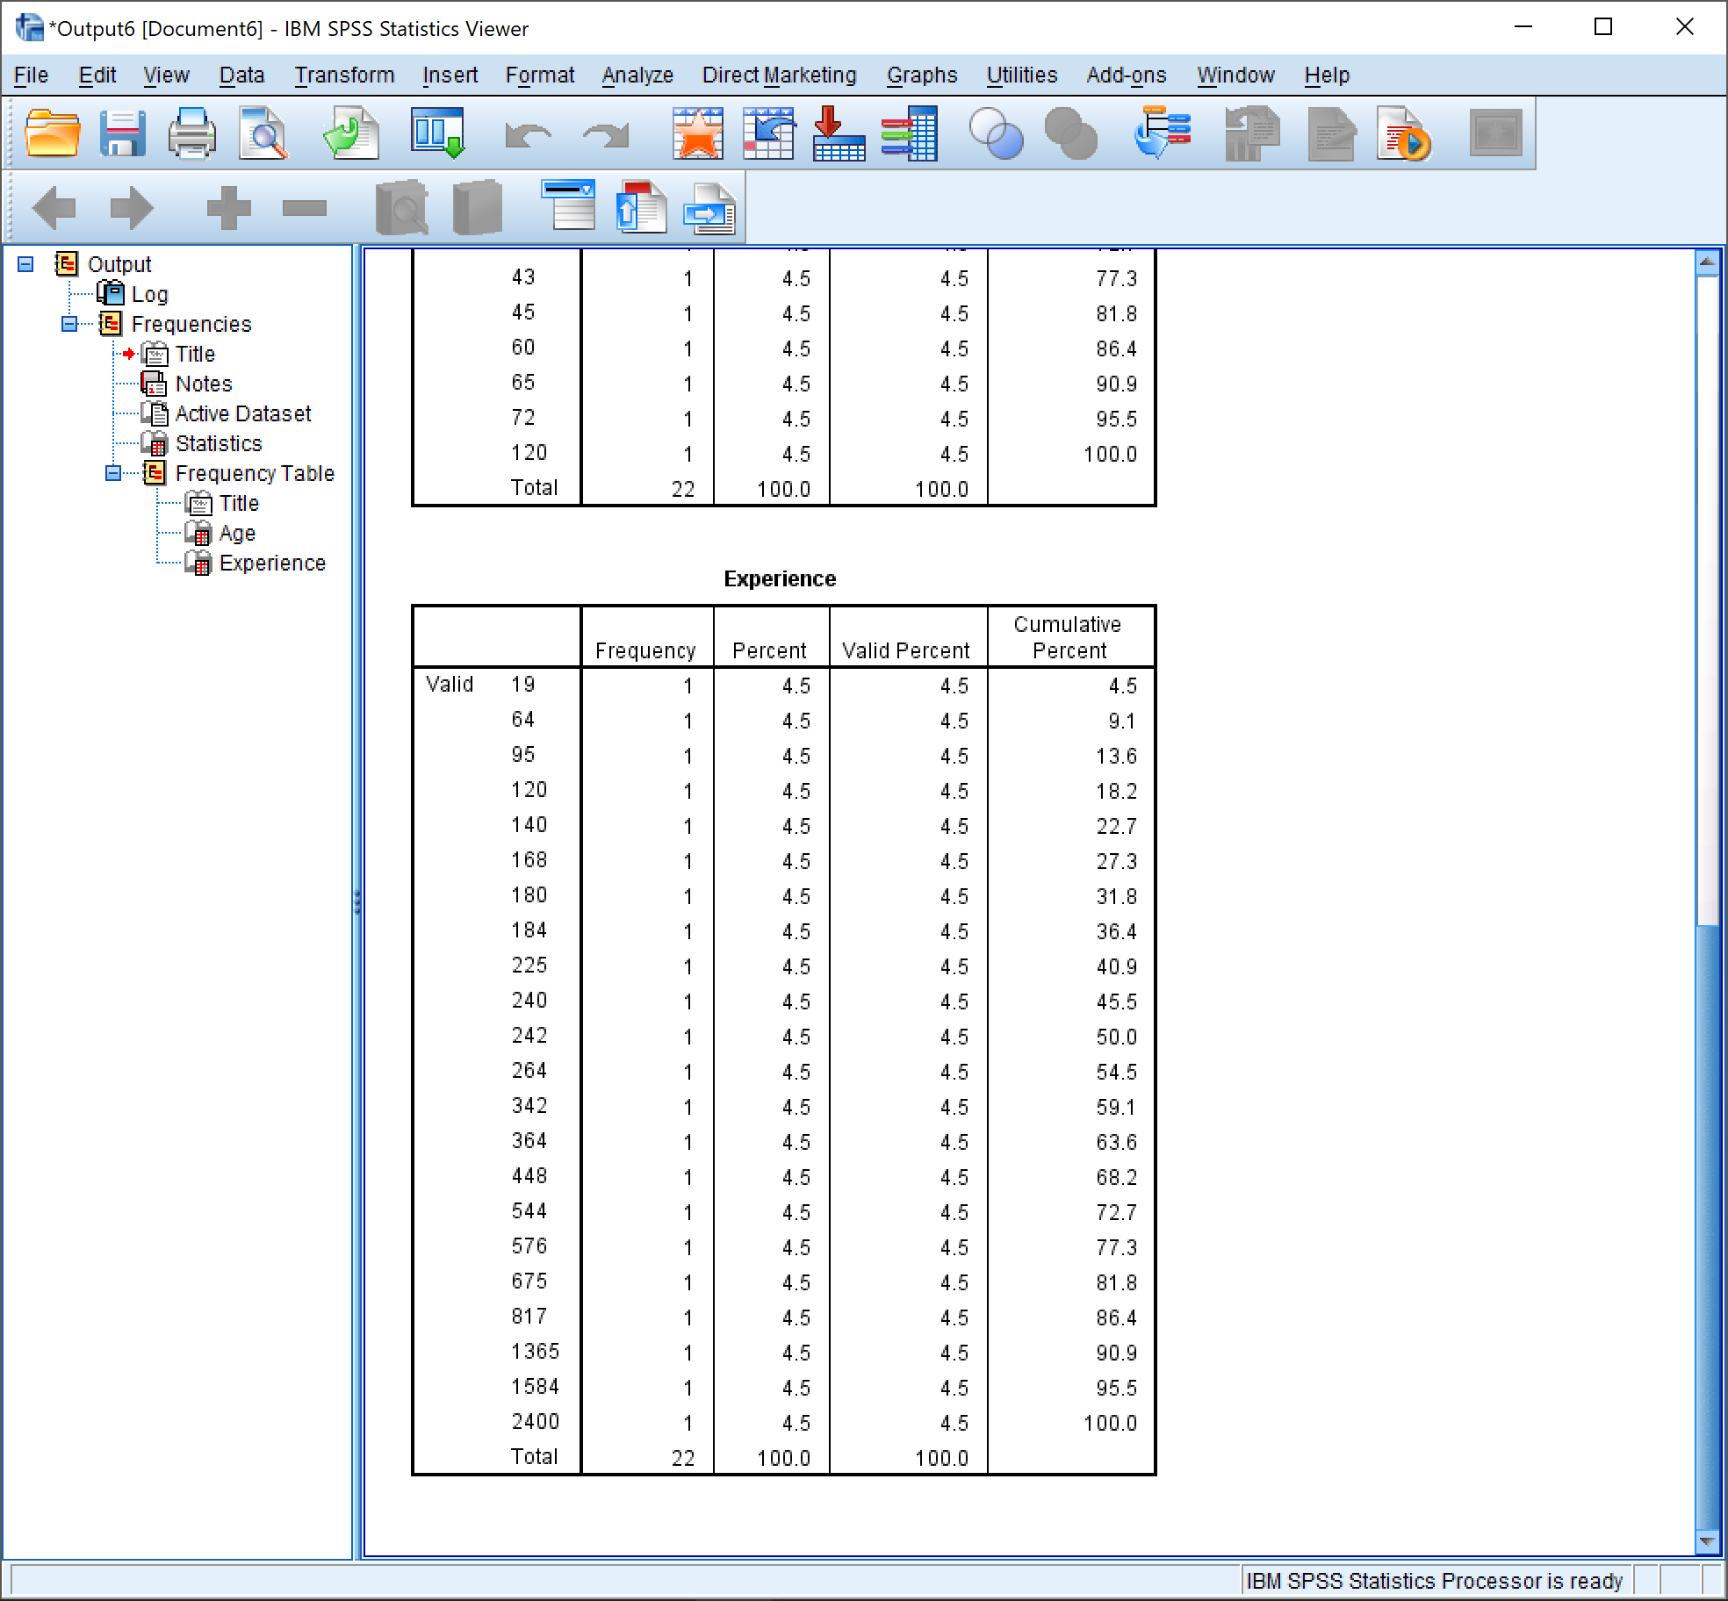

*Page 2*

# P-P Plots

We can also create P-P plots from the variables in our data set to analyze the deviation of those specific data sets.

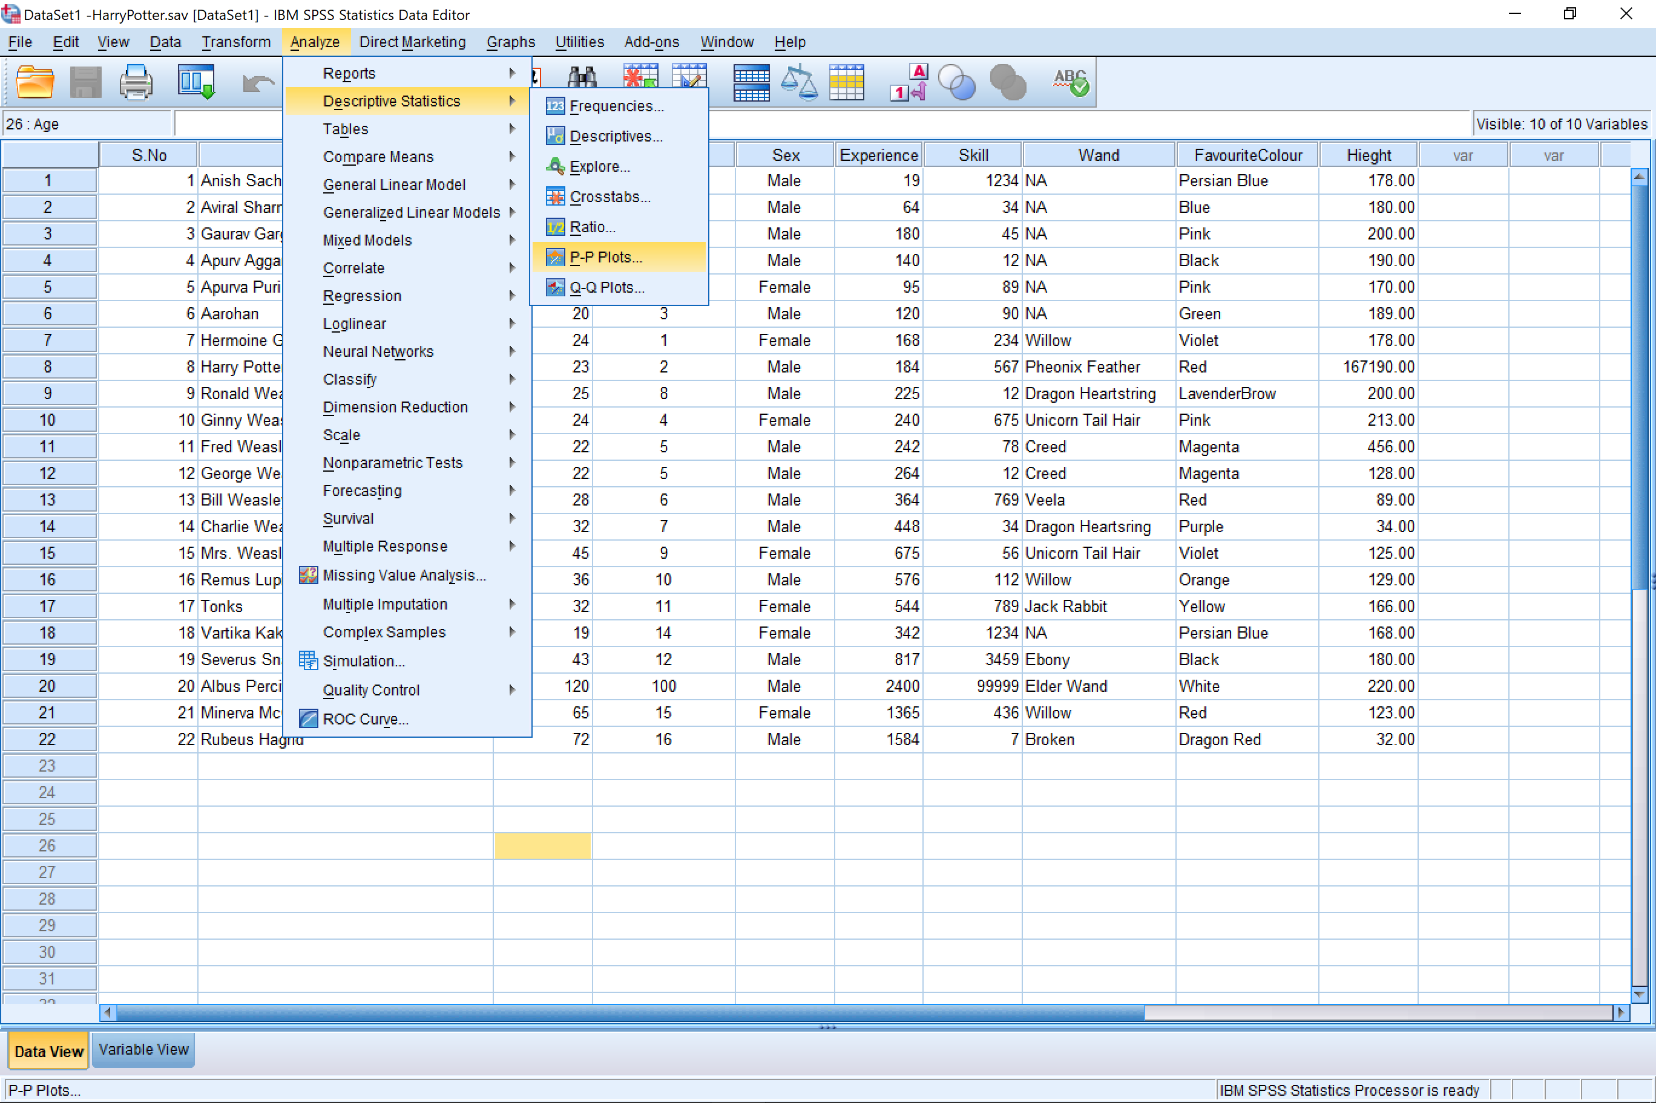

# P-P Plot Result (Age)

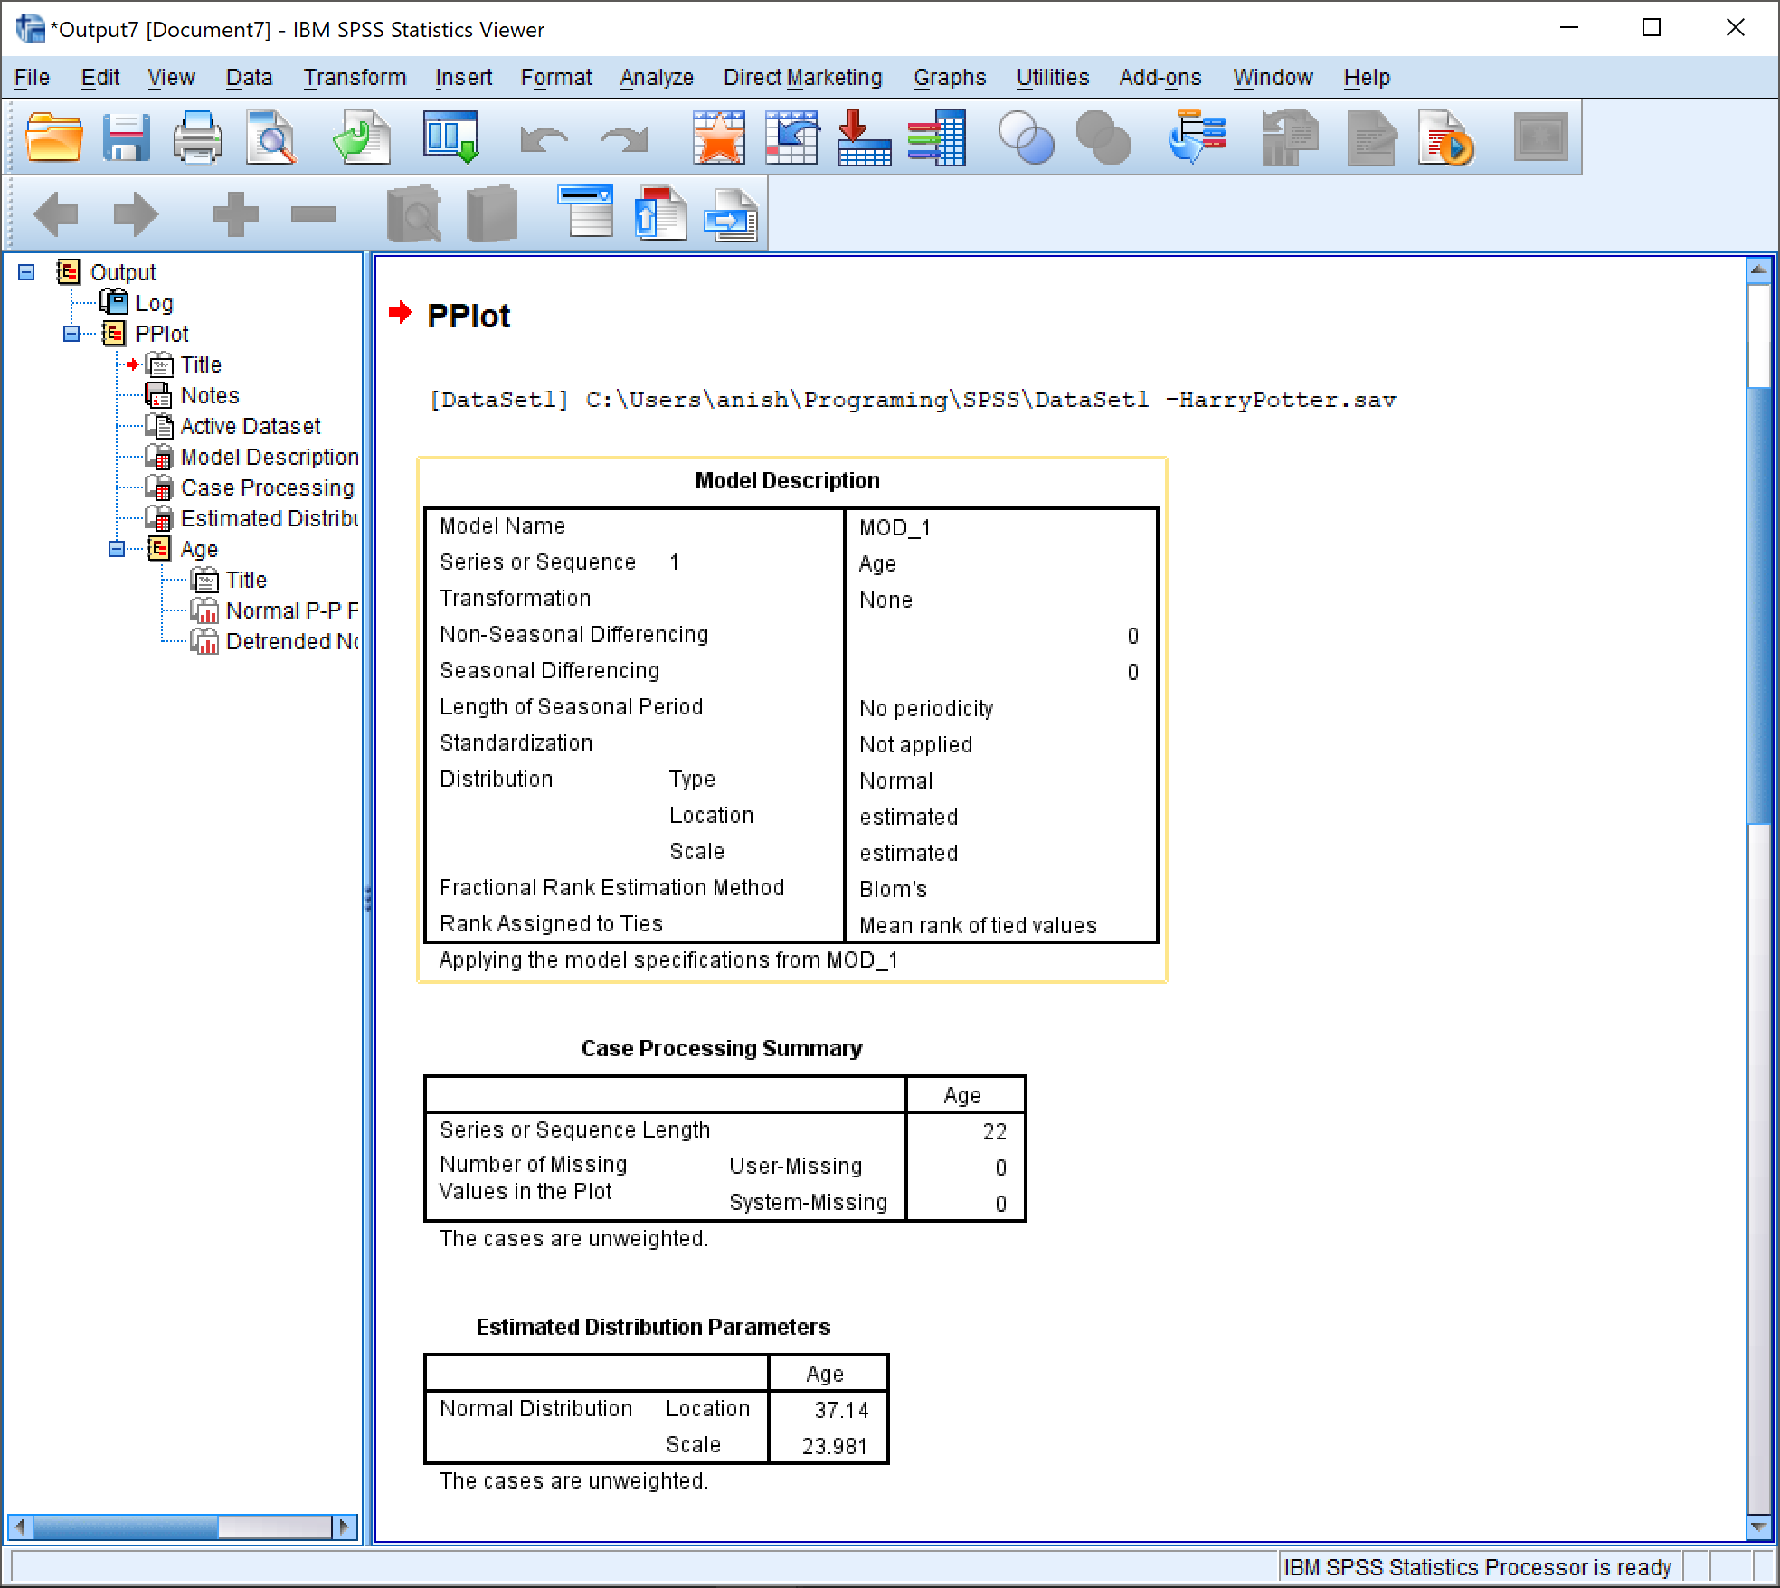

*Page 1*

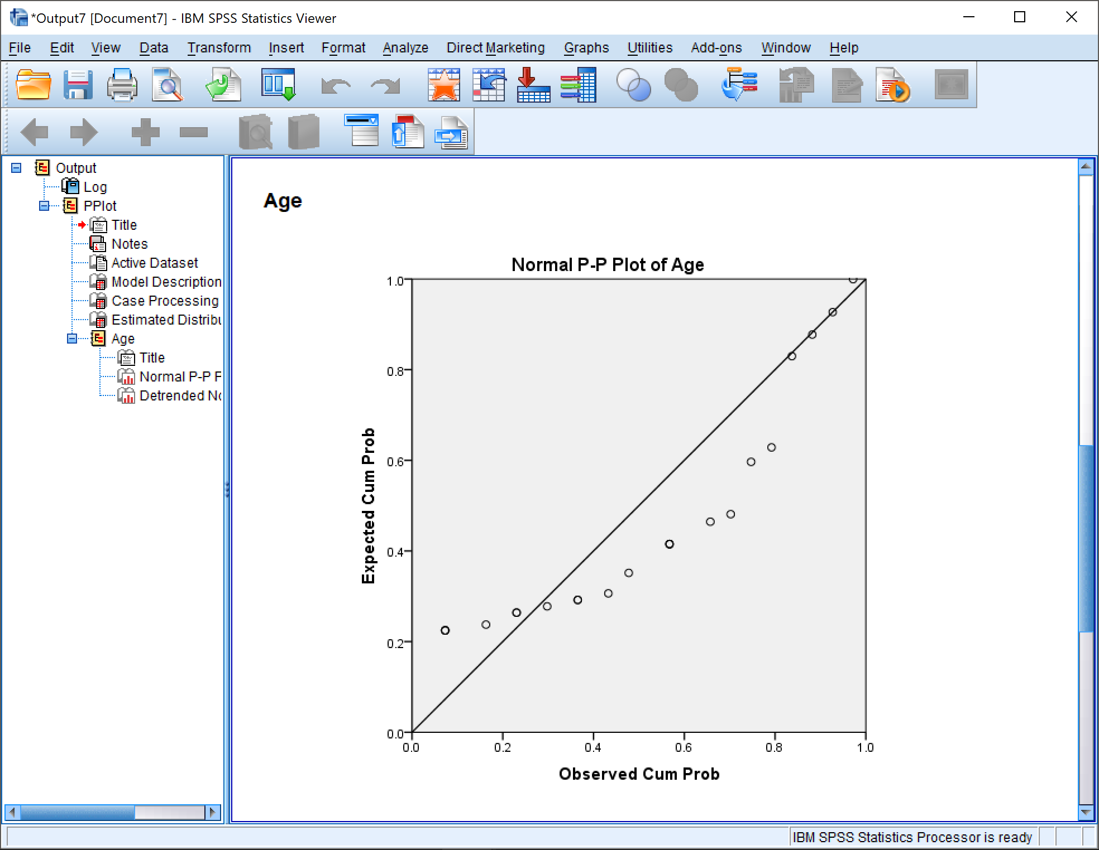

*Page 2*

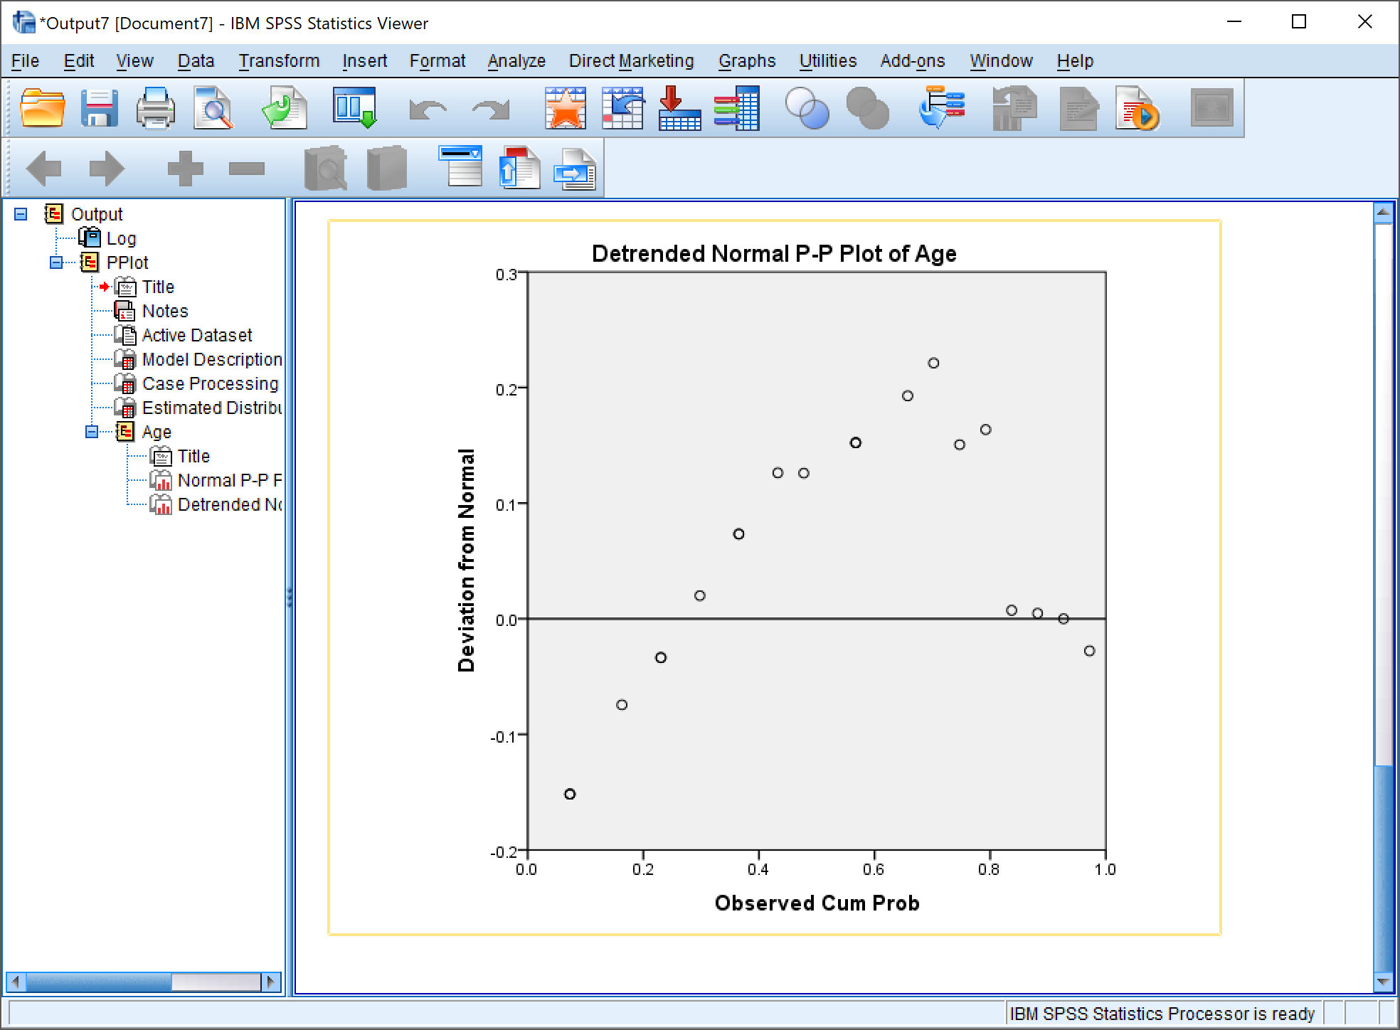

*Page 3*

# Conclusion

1. Frequency tables show us vivid statistical interpretation of data.
2. Frequency curves and P-P Plots show us the skewness and kurtosis of the data pictorially.

# Precautions

1. Curve of symmetry should be judged carefully.
2. Do note that quartiles divide distribution into 4 equal parts.
3. Only variables whose grouping makes logical sence and adds meaning to the data should be grouped together for interpretation.

Objective 5: Correlation, Linear Regression and Histograms

**Inputs :** HarryPotter.sav

# Procedure

1. Analyze -> Descriptive Statistics -> Frequencies



1. Add the variables you wish to use to the variables column.



1. Select -> Charts

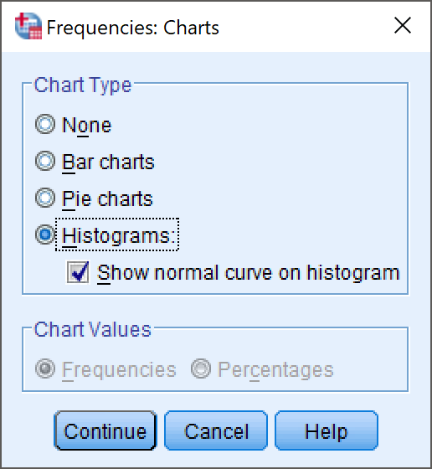

1. Then click on continue to create Chart

# Result

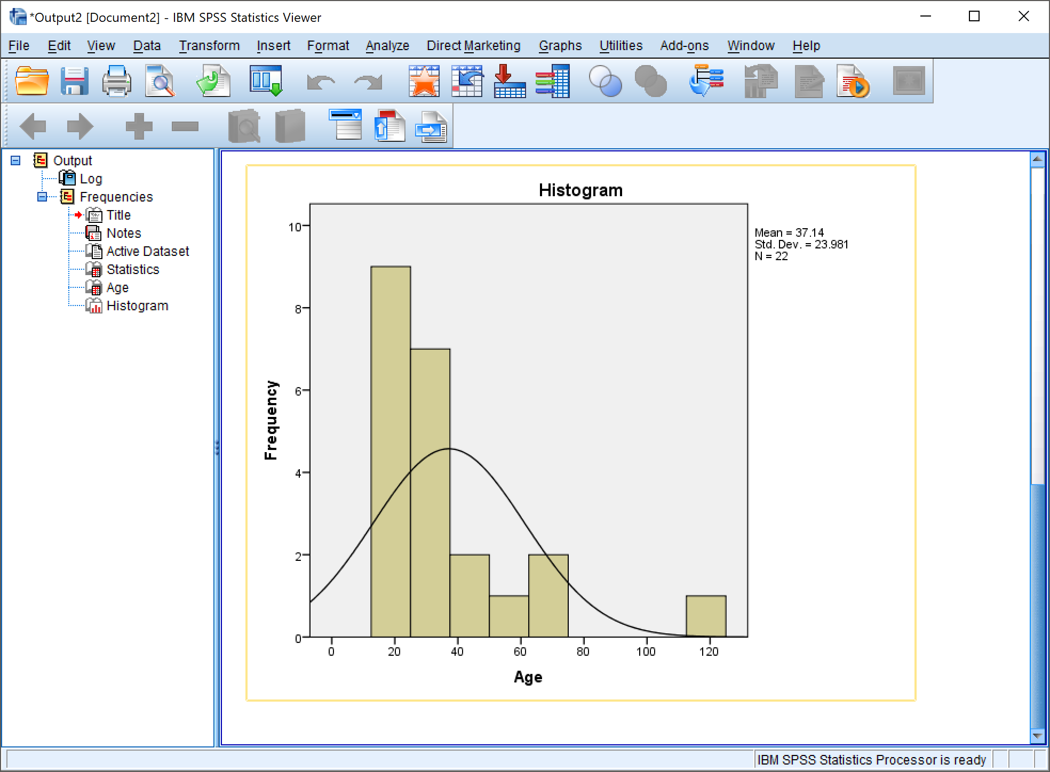

*Histogram with Frequency Curve*

Correlation

# Procedure

1. Analyze -> Correlate -> Bivariate

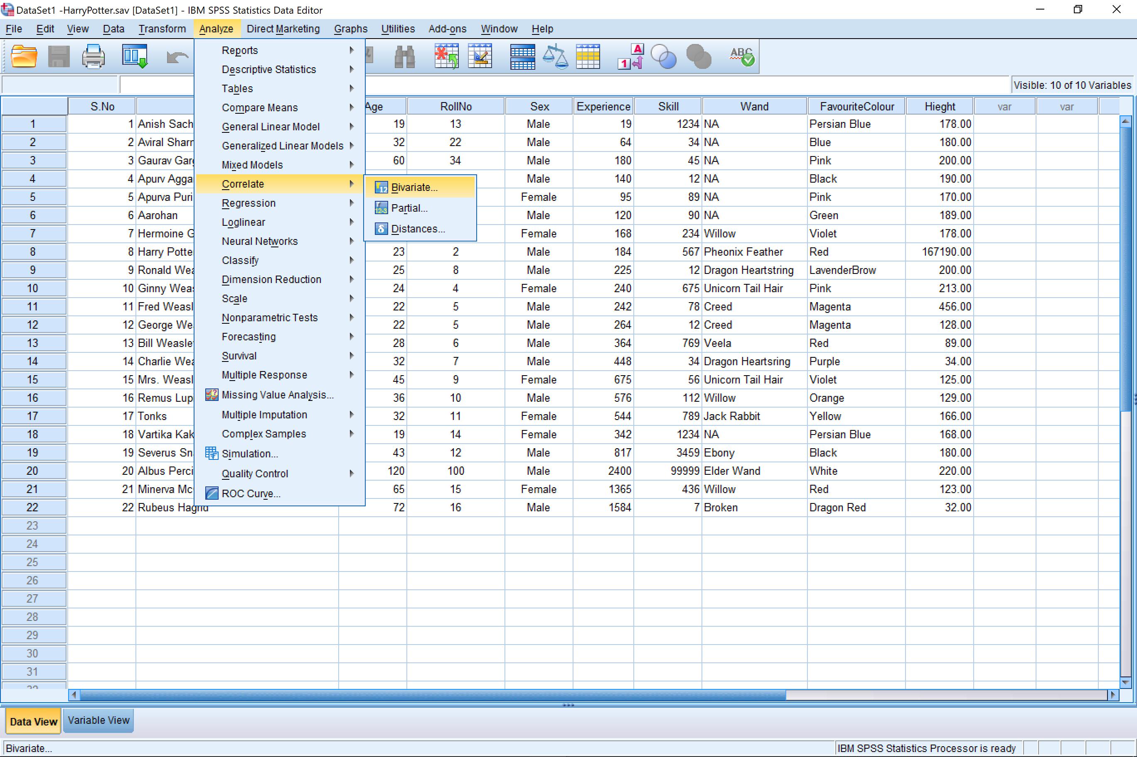

1. Select the variables you wish to check for correlation.

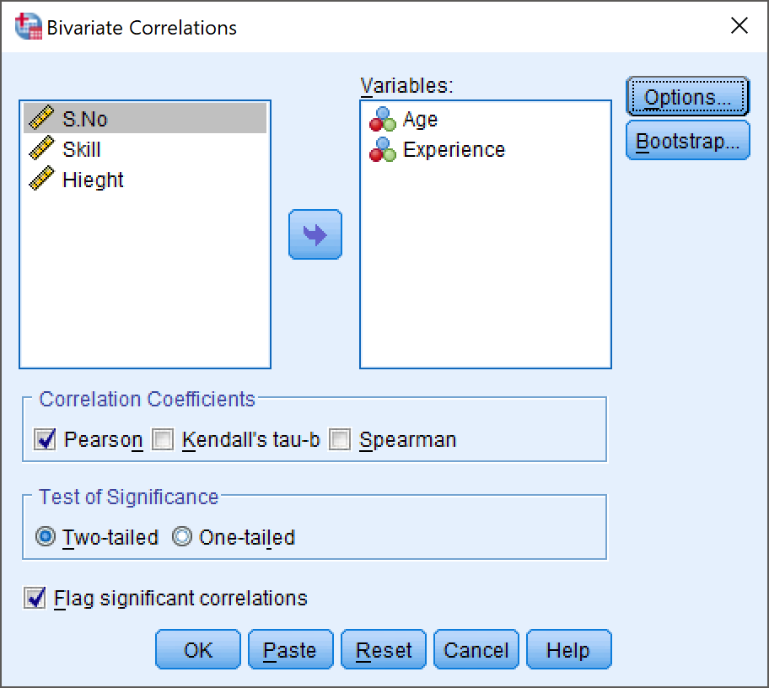

1. Select the options tab from the menu and select the properties you want in your correlation table.

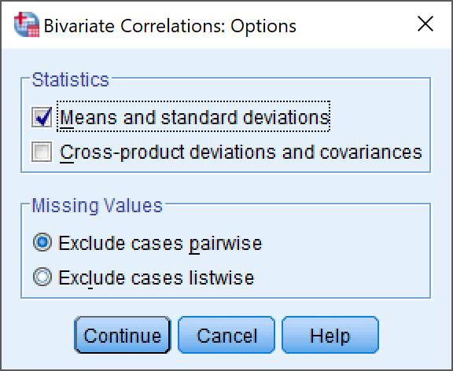

# Result

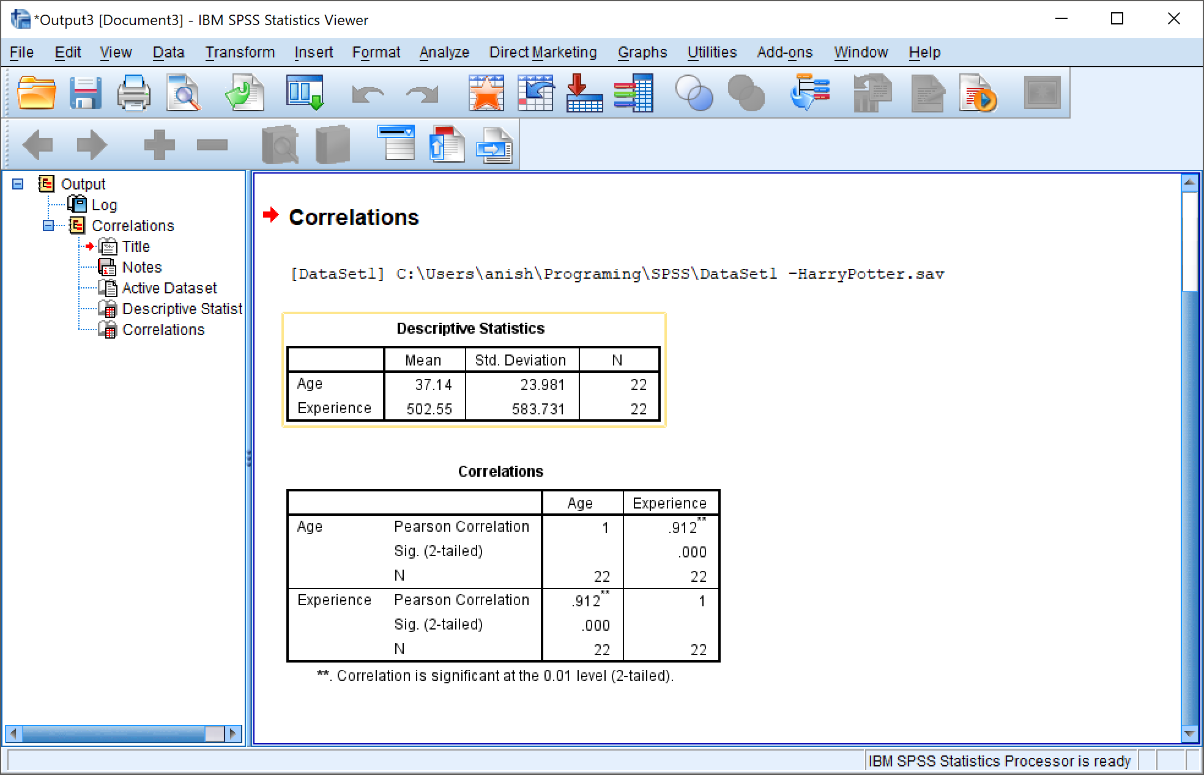

Linear Regression

# Procedure

1. Analyze -> Regression -> Linear Regression

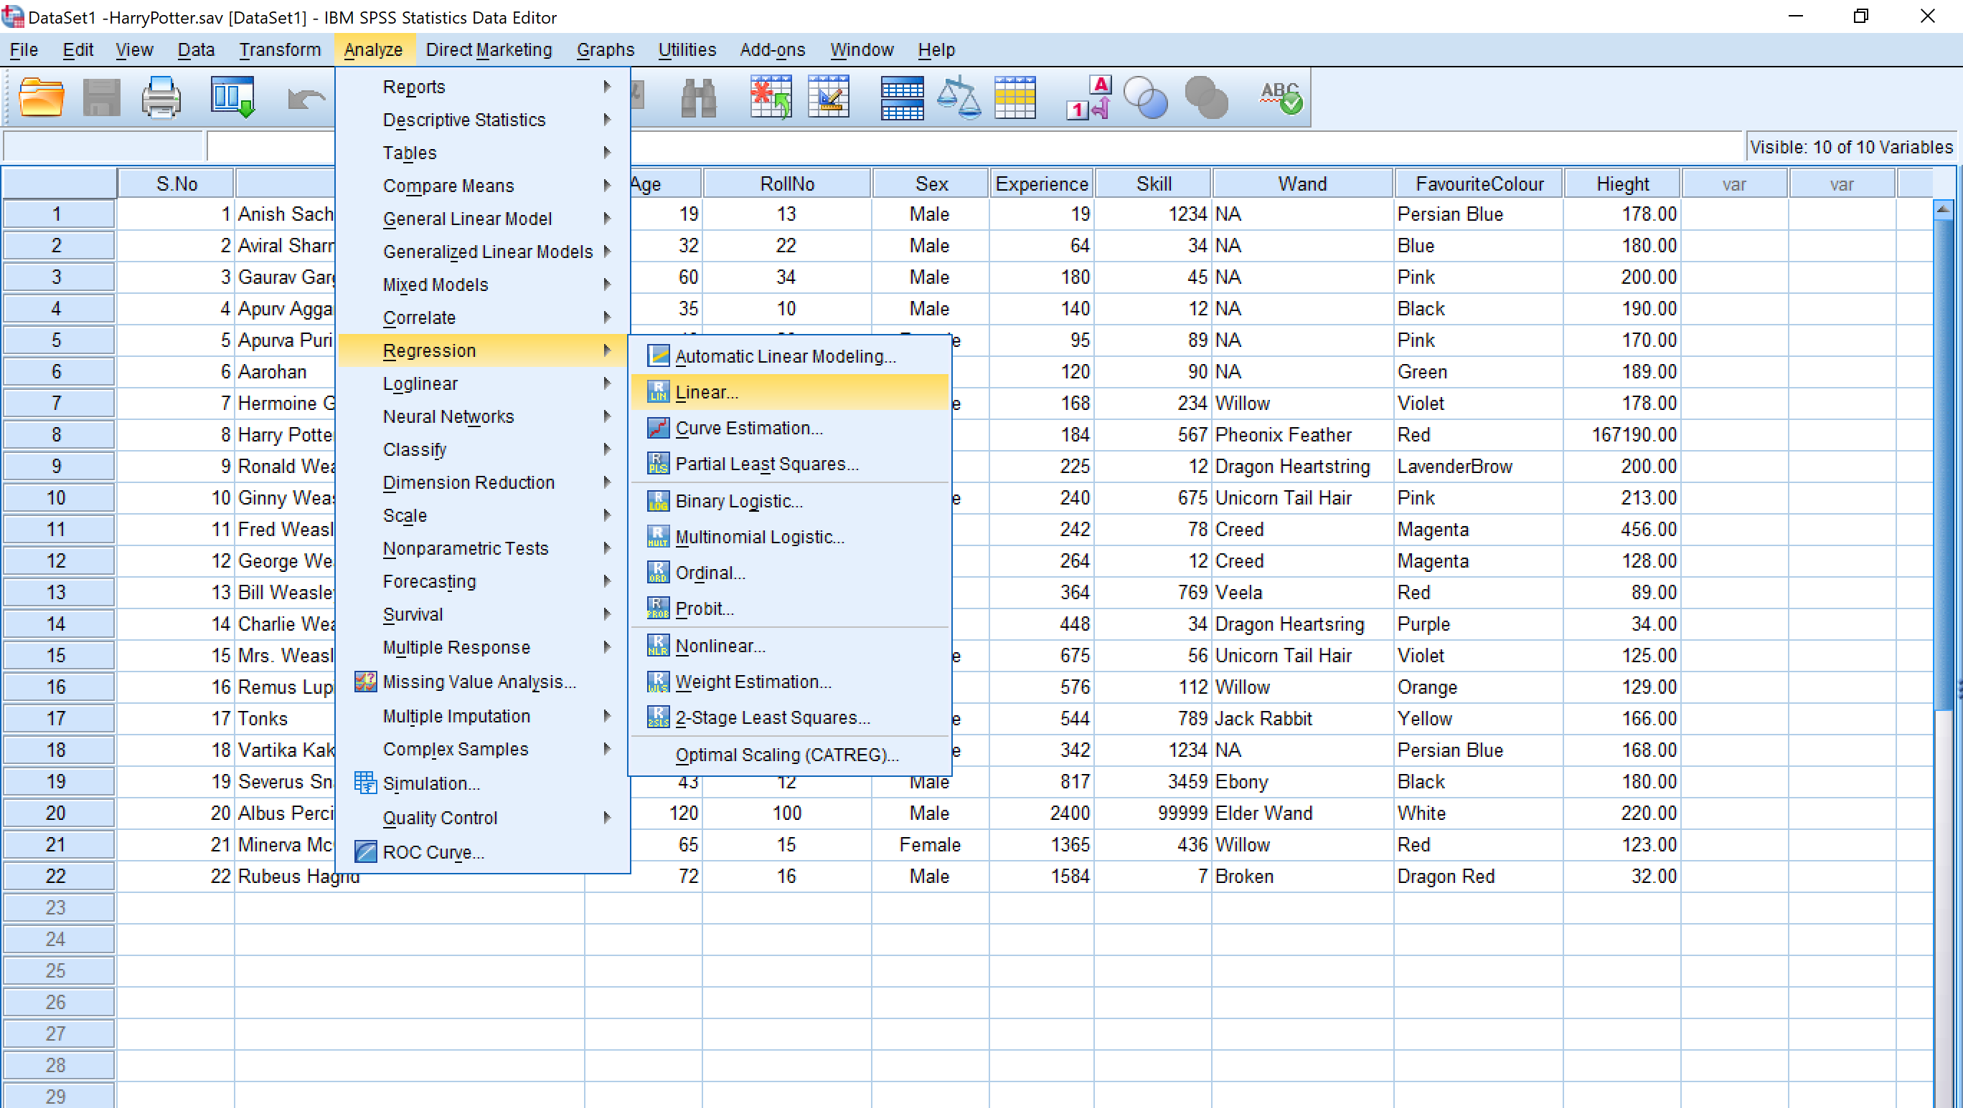

1. Select your dependent and independent variables

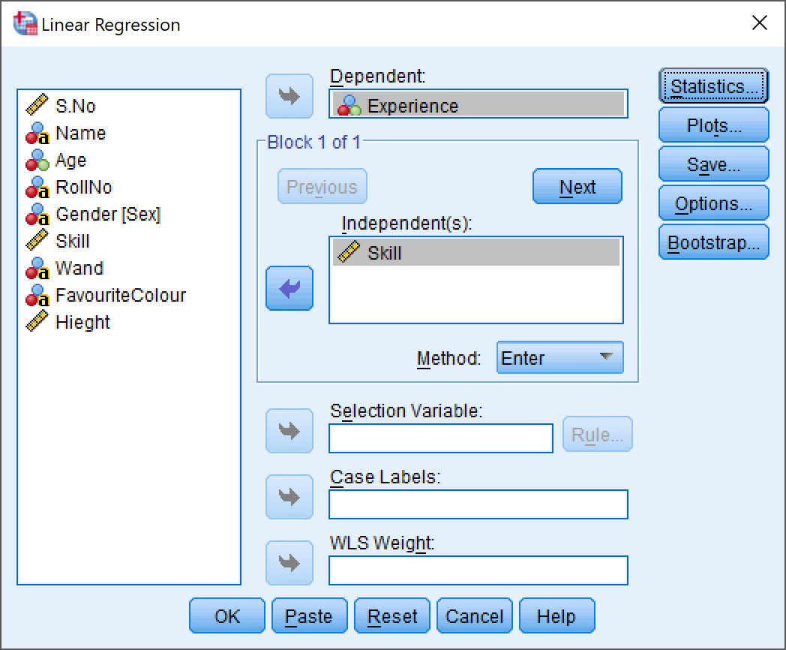

1. Select the statistics tab from the menu, and then select the properties you want.

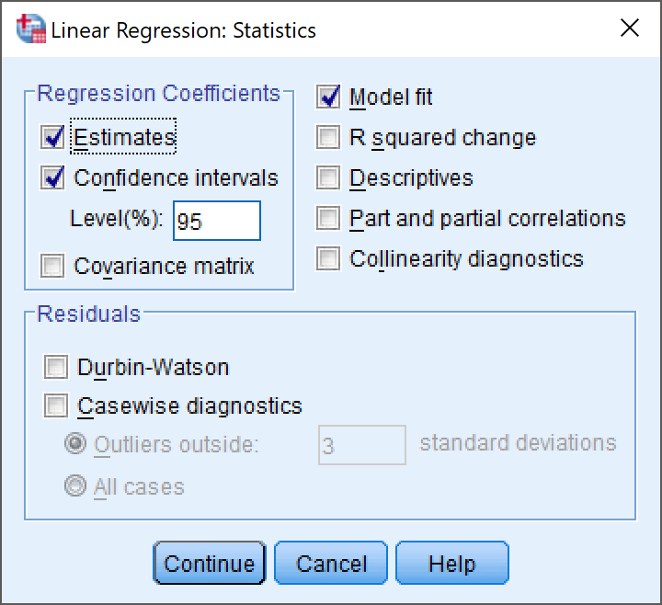

# Result

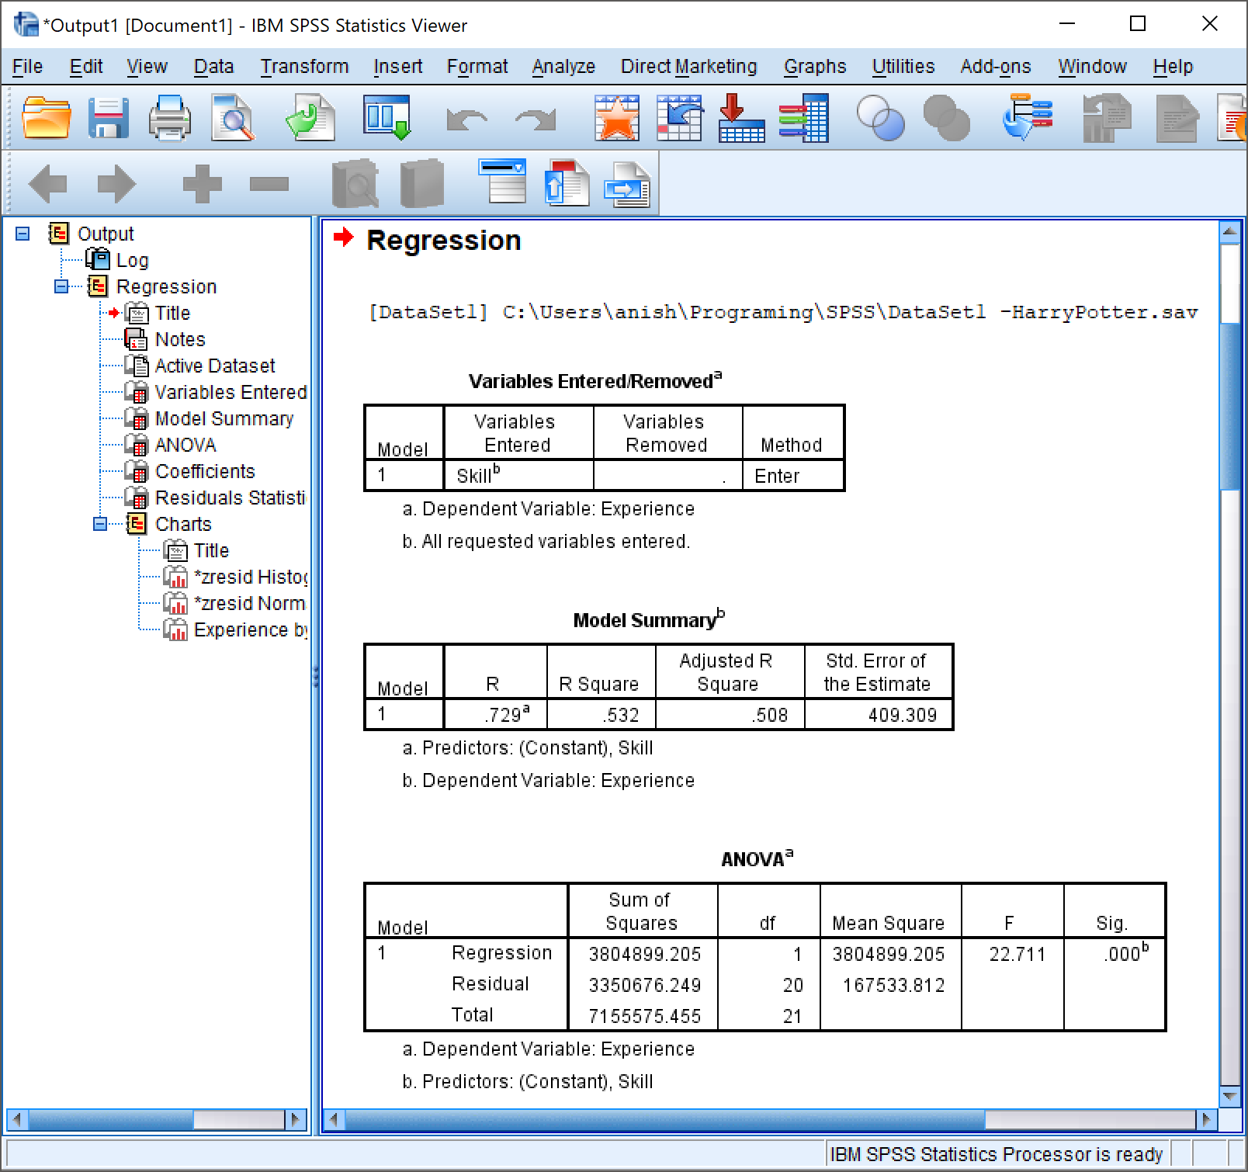

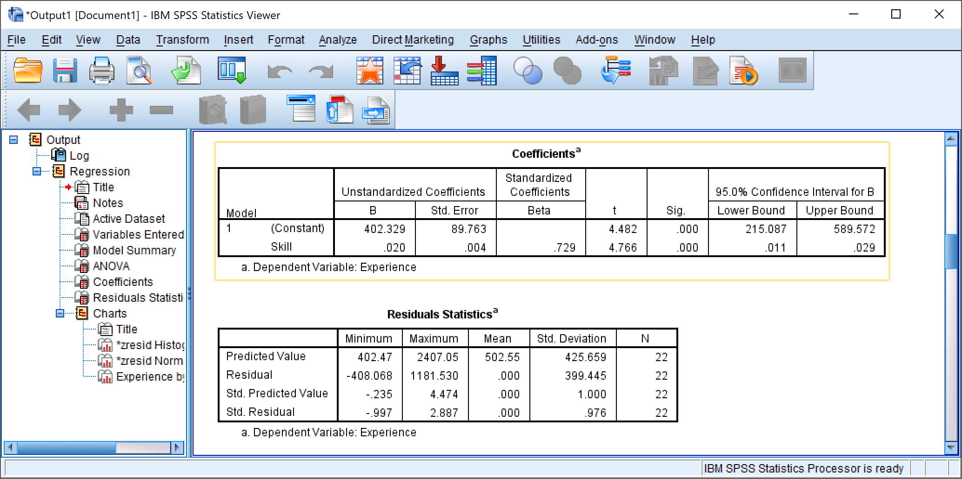

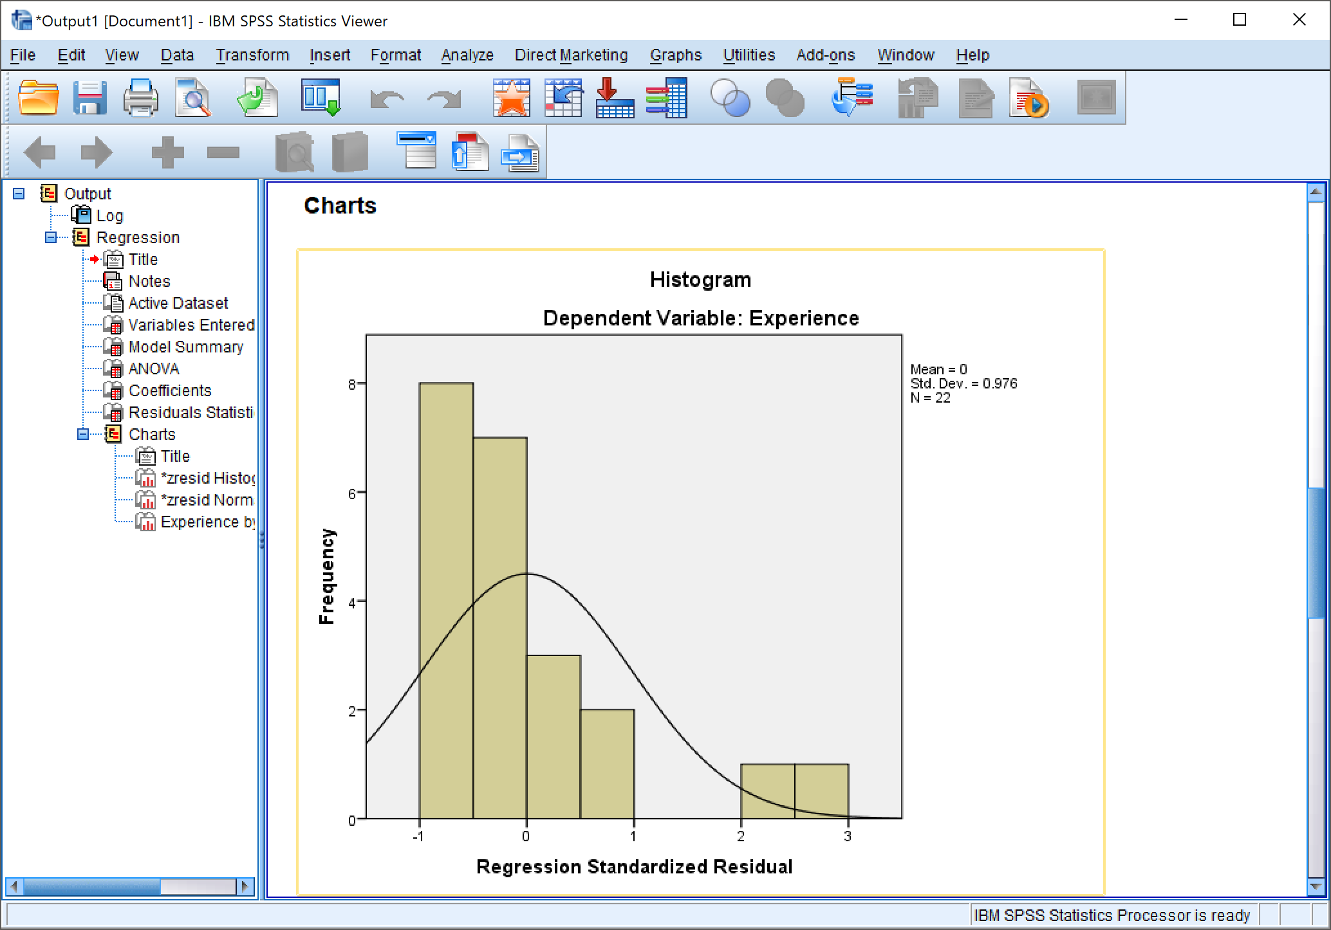

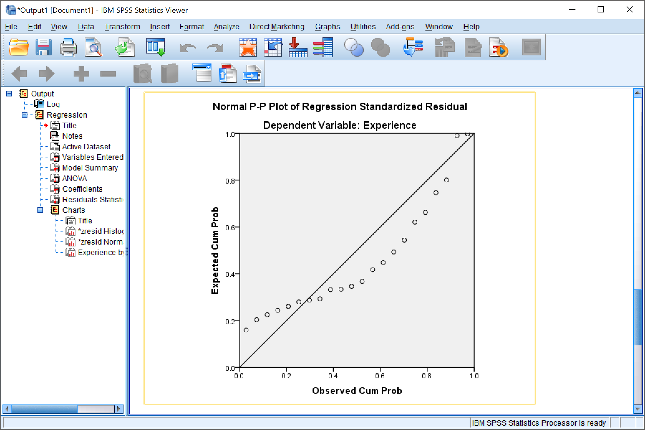

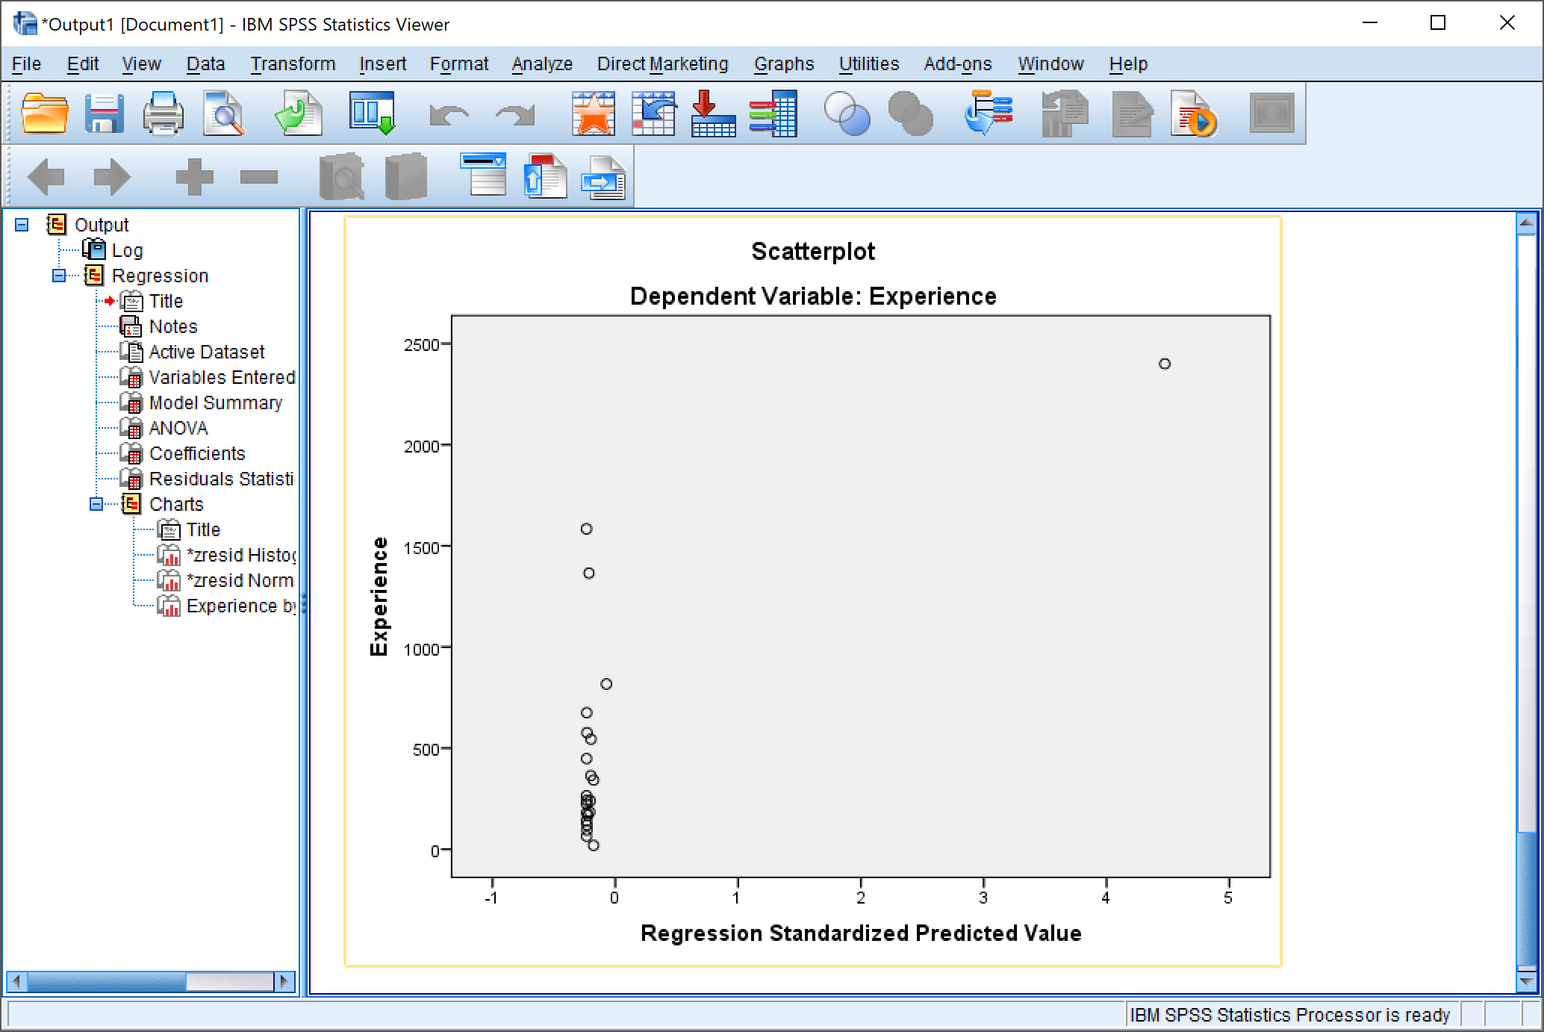

# Precautions

1. The independent and dependent variable in linear regression has to be selected carefully, to avoid any logical mistake.
2. Be sure to select the option ‘Histogram’ in the charts option in the frequencies menu, to obtain a distribution in the form of a histogram.
3. The correlation coefficient needs to be selected according to the need of the statistical data base. E.g. I have selected the Pearson’s coefficient.
4. One should carefully select single tailed or double tailed plot in regression.

# Conclusion

1. We conclude that one can easily represent any data in the form of a histogram and see the distribution curve through it using descriptive analytics.
2. Using the correlation functionality present in SPS Statistics, we can find the linear correlation between any two variables present in our data set and further study them by viewing their properties.
3. Using the linear Regression functionality present in SPS Statistics we can draw the regression between a dependent and any number of independent variables. We can also change the properties of the curves obtained and study them characteristically.

Objective 6: Chi – Square (χ2) Test

**Input:** HarryPotter_DataSet.sav

# Procedure

## *Independent Test*

1. Analyze -> Non-parametric Test -> Legacy Dialogs -> Chi Square

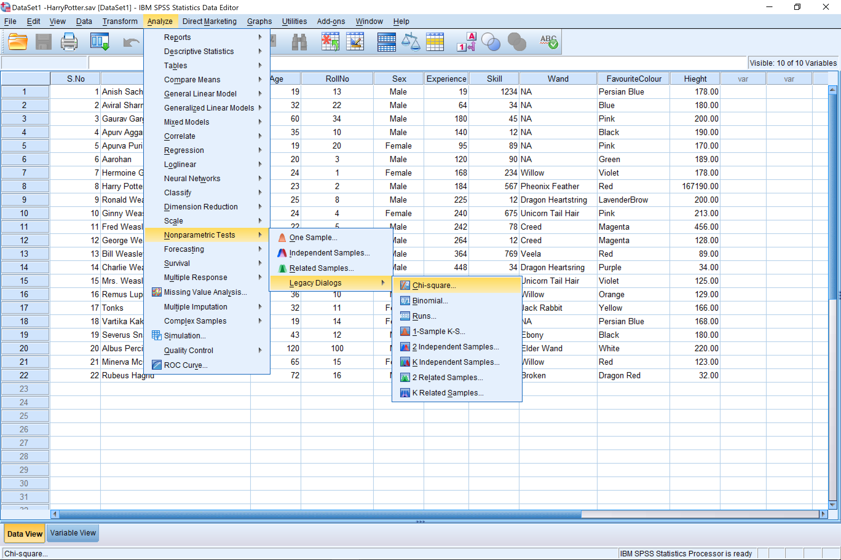

The Chi-Square (χ2) functionality present in SPSS statistics would then allow us to find the Chi – square plot of any variable that we have selected.

1. Then the select the normal / ordinal variable for which you want to perform the chi-square (χ2) test. And then select OK to proceed.

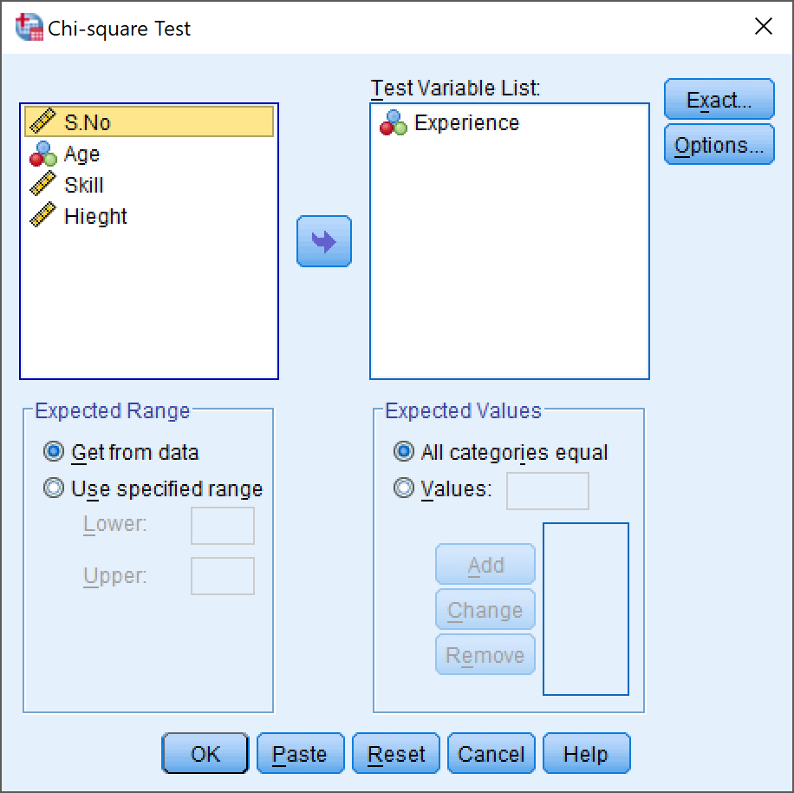

## Results For Chi- square (χ2) Test

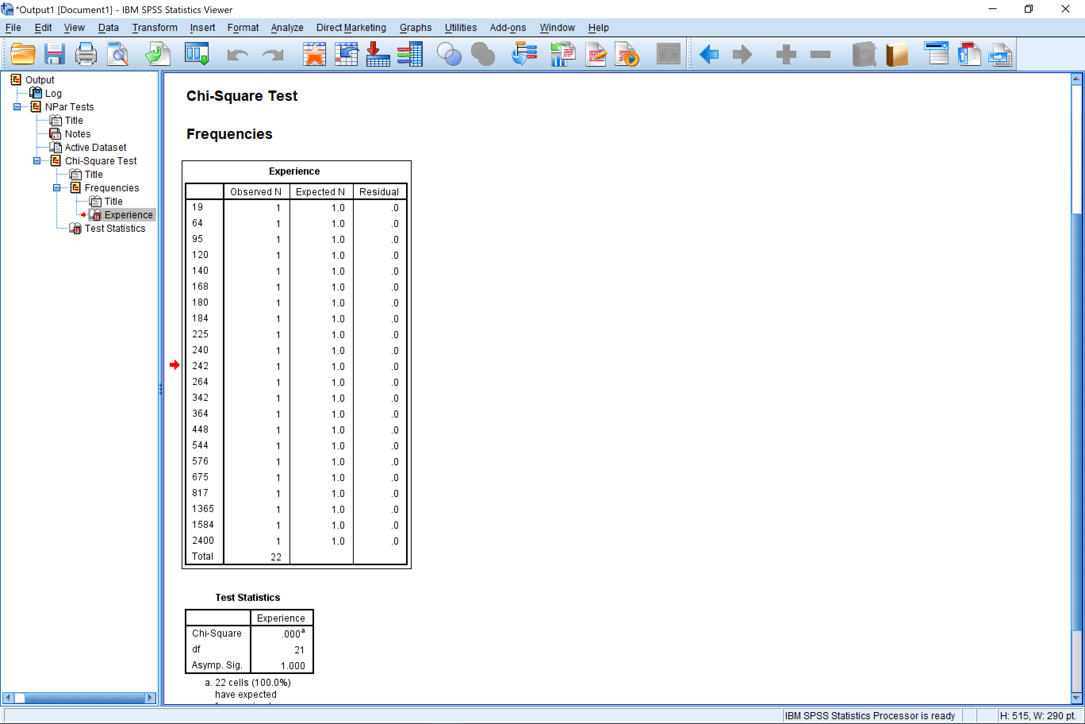

## *Dependent Variable Test*

1. Analyze -> Descriptive Statistics -> Crosstabs

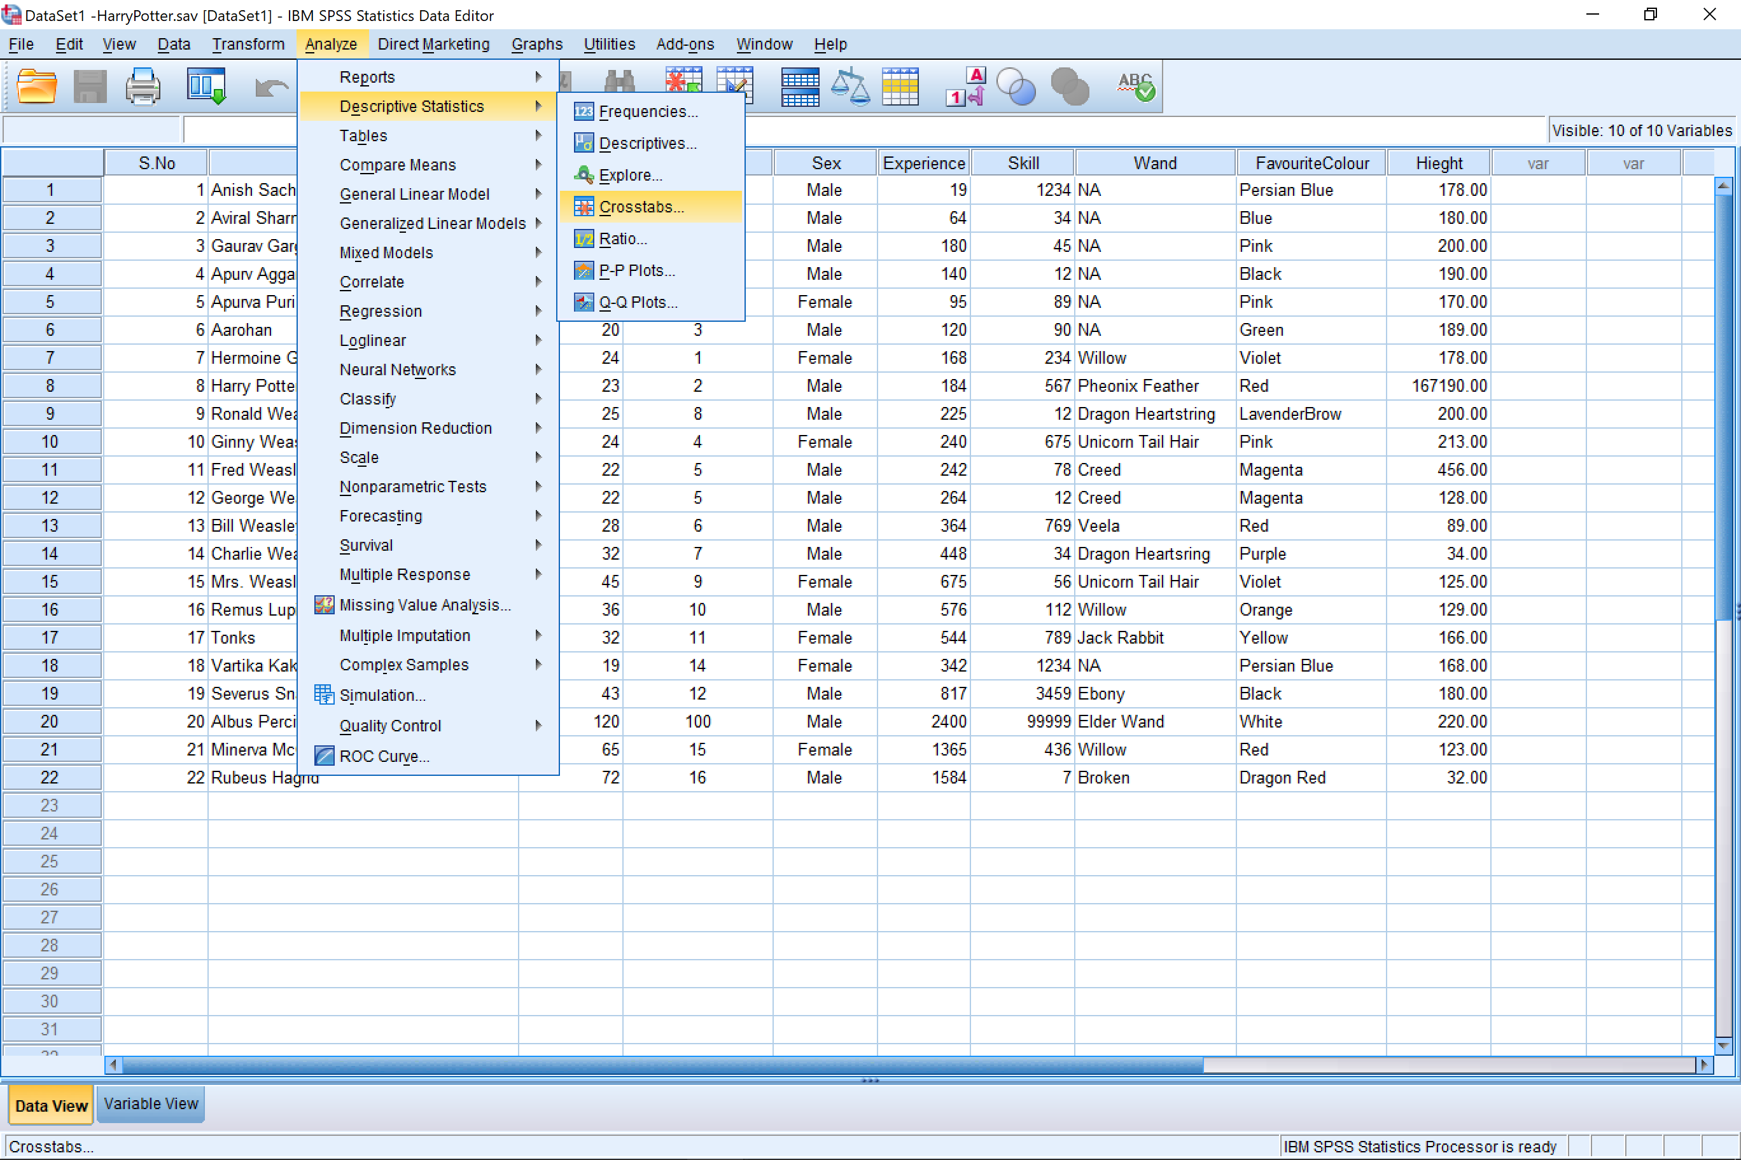

1. Then from the menu box select the data that you want you analyze for the dependent test in Crosstabs.

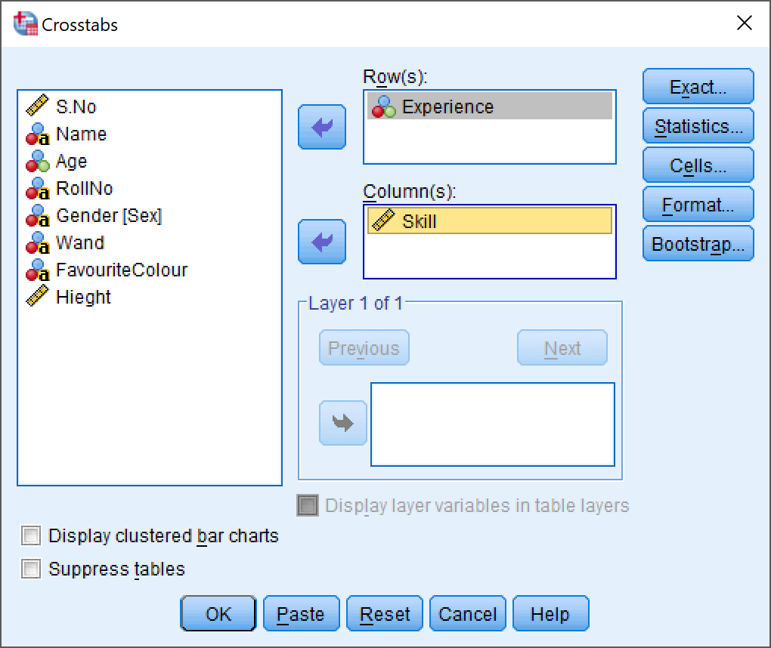

1. You can further refine your result by selecting the statistics tab from the crosstabs menu and selecting the desired options for your chart.

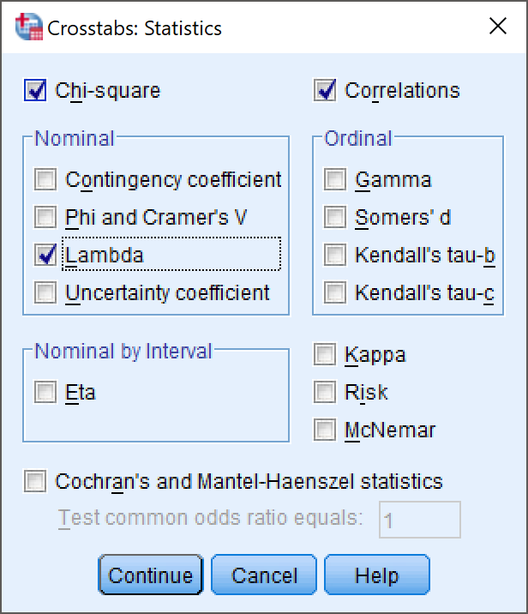

1. After selecting the parameters of your data, click on continue and then click on OK for IBM SPSS Statistics to prepare your result.

## Result For Dependent Test

|  |  |  |  |  |  |  |
| --- | --- | --- | --- | --- | --- | --- |
| **Case Processing Summary** | | | | | | |
|  | Cases | | | | | |
| Valid | | Missing | | Total | |
| N | Percent | N | Percent | N | Percent |
| Experience * Skill | 22 | 100.0% | 0 | 0.0% | 22 | 100.0% |

|  |  |  |  |  |  |  |  |  |
| --- | --- | --- | --- | --- | --- | --- | --- | --- |
| **Experience * Skill Crosstabulation** | | | | | | | | |
| Count | | | | | | | | |
|  | | Skill | | | | | | |
| 7 | 12 | 34 | 45 | 56 | 78 | 89 |
| Experience | 19 | 0 | 0 | 0 | 0 | 0 | 0 | 0 |
| 64 | 0 | 0 | 1 | 0 | 0 | 0 | 0 |
| 95 | 0 | 0 | 0 | 0 | 0 | 0 | 1 |
| 120 | 0 | 0 | 0 | 0 | 0 | 0 | 0 |
| 140 | 0 | 1 | 0 | 0 | 0 | 0 | 0 |
| 168 | 0 | 0 | 0 | 0 | 0 | 0 | 0 |
| 180 | 0 | 0 | 0 | 1 | 0 | 0 | 0 |
| 184 | 0 | 0 | 0 | 0 | 0 | 0 | 0 |
| 225 | 0 | 1 | 0 | 0 | 0 | 0 | 0 |
| 240 | 0 | 0 | 0 | 0 | 0 | 0 | 0 |
| 242 | 0 | 0 | 0 | 0 | 0 | 1 | 0 |
| 264 | 0 | 1 | 0 | 0 | 0 | 0 | 0 |
| 342 | 0 | 0 | 0 | 0 | 0 | 0 | 0 |
| 364 | 0 | 0 | 0 | 0 | 0 | 0 | 0 |
| 448 | 0 | 0 | 1 | 0 | 0 | 0 | 0 |
| 544 | 0 | 0 | 0 | 0 | 0 | 0 | 0 |
| 576 | 0 | 0 | 0 | 0 | 0 | 0 | 0 |
| 675 | 0 | 0 | 0 | 0 | 1 | 0 | 0 |
| 817 | 0 | 0 | 0 | 0 | 0 | 0 | 0 |
| 1365 | 0 | 0 | 0 | 0 | 0 | 0 | 0 |
| 1584 | 1 | 0 | 0 | 0 | 0 | 0 | 0 |
| 2400 | 0 | 0 | 0 | 0 | 0 | 0 | 0 |
| Total | | 1 | 3 | 2 | 1 | 1 | 1 | 1 |

|  |  |  |  |  |  |  |  |  |
| --- | --- | --- | --- | --- | --- | --- | --- | --- |
| **Experience * Skill Crosstabulation** | | | | | | | | |
| Count | | | | | | | | |
|  | | Skill | | | | | | |
| 90 | 112 | 234 | 436 | 567 | 675 | 769 |
| Experience | 19 | 0 | 0 | 0 | 0 | 0 | 0 | 0 |
| 64 | 0 | 0 | 0 | 0 | 0 | 0 | 0 |
| 95 | 0 | 0 | 0 | 0 | 0 | 0 | 0 |
| 120 | 1 | 0 | 0 | 0 | 0 | 0 | 0 |
| 140 | 0 | 0 | 0 | 0 | 0 | 0 | 0 |
| 168 | 0 | 0 | 1 | 0 | 0 | 0 | 0 |
| 180 | 0 | 0 | 0 | 0 | 0 | 0 | 0 |
| 184 | 0 | 0 | 0 | 0 | 1 | 0 | 0 |
| 225 | 0 | 0 | 0 | 0 | 0 | 0 | 0 |
| 240 | 0 | 0 | 0 | 0 | 0 | 1 | 0 |
| 242 | 0 | 0 | 0 | 0 | 0 | 0 | 0 |
| 264 | 0 | 0 | 0 | 0 | 0 | 0 | 0 |
| 342 | 0 | 0 | 0 | 0 | 0 | 0 | 0 |
| 364 | 0 | 0 | 0 | 0 | 0 | 0 | 1 |
| 448 | 0 | 0 | 0 | 0 | 0 | 0 | 0 |
| 544 | 0 | 0 | 0 | 0 | 0 | 0 | 0 |
| 576 | 0 | 1 | 0 | 0 | 0 | 0 | 0 |
| 675 | 0 | 0 | 0 | 0 | 0 | 0 | 0 |
| 817 | 0 | 0 | 0 | 0 | 0 | 0 | 0 |
| 1365 | 0 | 0 | 0 | 1 | 0 | 0 | 0 |
| 1584 | 0 | 0 | 0 | 0 | 0 | 0 | 0 |
| 2400 | 0 | 0 | 0 | 0 | 0 | 0 | 0 |
| Total | | 1 | 1 | 1 | 1 | 1 | 1 | 1 |

And other such tables of Experience * skill Cross tabulation…

|  |  |  |  |  |  |  |  |  |  |  |
| --- | --- | --- | --- | --- | --- | --- | --- | --- | --- | --- |
| **Chi-Square Tests** | | | | | | | | | | |
|  | | | | Value | df | | | | Asymp. Sig. (2-sided) | |
| Pearson Chi-Square | | | | 374.000a | 357 | | | | .257 | |
| Likelihood Ratio | | | | 123.869 | 357 | | | | 1.000 | |
| Linear-by-Linear Association | | | | 11.167 | 1 | | | | .001  *a. 396 cells (100.0%) have expected count less than 5. The minimum expected count is .05.* | |
| N of Valid Cases | | | | 22 |  | | | |  | |
| **Directional Measures** | | | | | | | | | | | | | | | | | | |
|  | | | | | | | | | | | | | Value | | | Asymp. Std. Errora | | |
| Nominal by Nominal | | Lambda | | | | | Symmetric | | | | | | .900 | | | .047 | | |
| Experience Dependent | | | | | | .810 | | | .086 | | |
| Skill Dependent | | | | | | 1.000 | | | .000 | | |
| Goodman and Kruskal tau | | | | | Experience Dependent | | | | | | .810 | | | .000 | | |
| Skill Dependent | | | | | | 1.000 | | | .000 | | |
| **Directional Measures** | | | | | | | | | | | | | | | | | | |
|  | | | | | | | | | | | | | | Approx. T | | | Approx. Sig.a | |
| Nominal by Nominal | | | Lambda | | | | | Symmetric | | | | | | 11.940 | | | .000 | |
| Experience Dependent | | | | | | 8.649 | | | .000 | |
| Skill Dependent | | | | | | 11.804 | | | .000 | |
| Goodman and Kruskal tau | | | | | Experience Dependent | | | | | |  | | | .490 | |
| Skill Dependent | | | | | |  | | | .490 | |
| a. Not assuming the null hypothesis. | | | | | | | | | | | | | | | | | | |
| b. Using the asymptotic standard error assuming the null hypothesis. | | | | | | | | | | | | | | | | | | |
| c. Based on chi-square approximation | | | | | | | | | | | | | | | | | | |
| **Symmetric Measures** | | | | | | | | | | | | | | | | | |
|  | | | | | | Value | | | | Asymp. Std. Errora | | Approx. Tb | | | Approx. Sig. | | |
| Interval by Interval | Pearson's R | | | | | .729 | | | | .189 | | 4.766 | | | .000c | | |
| Ordinal by Ordinal | Spearman Correlation | | | | | .196 | | | | .240 | | .892 | | | .383c | | |
| N of Valid Cases | | | | | | 22 | | | |  | |  | | |  | | |
| a. Not assuming the null hypothesis. | | | | | | | | | | | | | | | | | |
| b. Using the asymptotic standard error assuming the null hypothesis. | | | | | | | | | | | | | | | | | |
| c. Based on normal approximation. | | | | | | | | | | | | | | | | | |

# Precautions

1. The data variables should be selected carefully while performing the chi-square (χ2) test or cross tabulation.
2. The properties of the curve should be chose carefully whilst in the statistics dialog box for desired results.

# Conclusion

We can conclude that SPSS Statistics software is capable of correctly and accurately performing the chi – square (χ2) test and cross tabulation and this tool can be used by scientists and mathematicians for calculating and testing their hypotheses.

Objective 7: T–Test

**Inputs:** HarryPotter_DataSet.sav

# One-Sample T –Test

## Procedure

1. Analyze -> Compare Means -> One-Sample T-Test

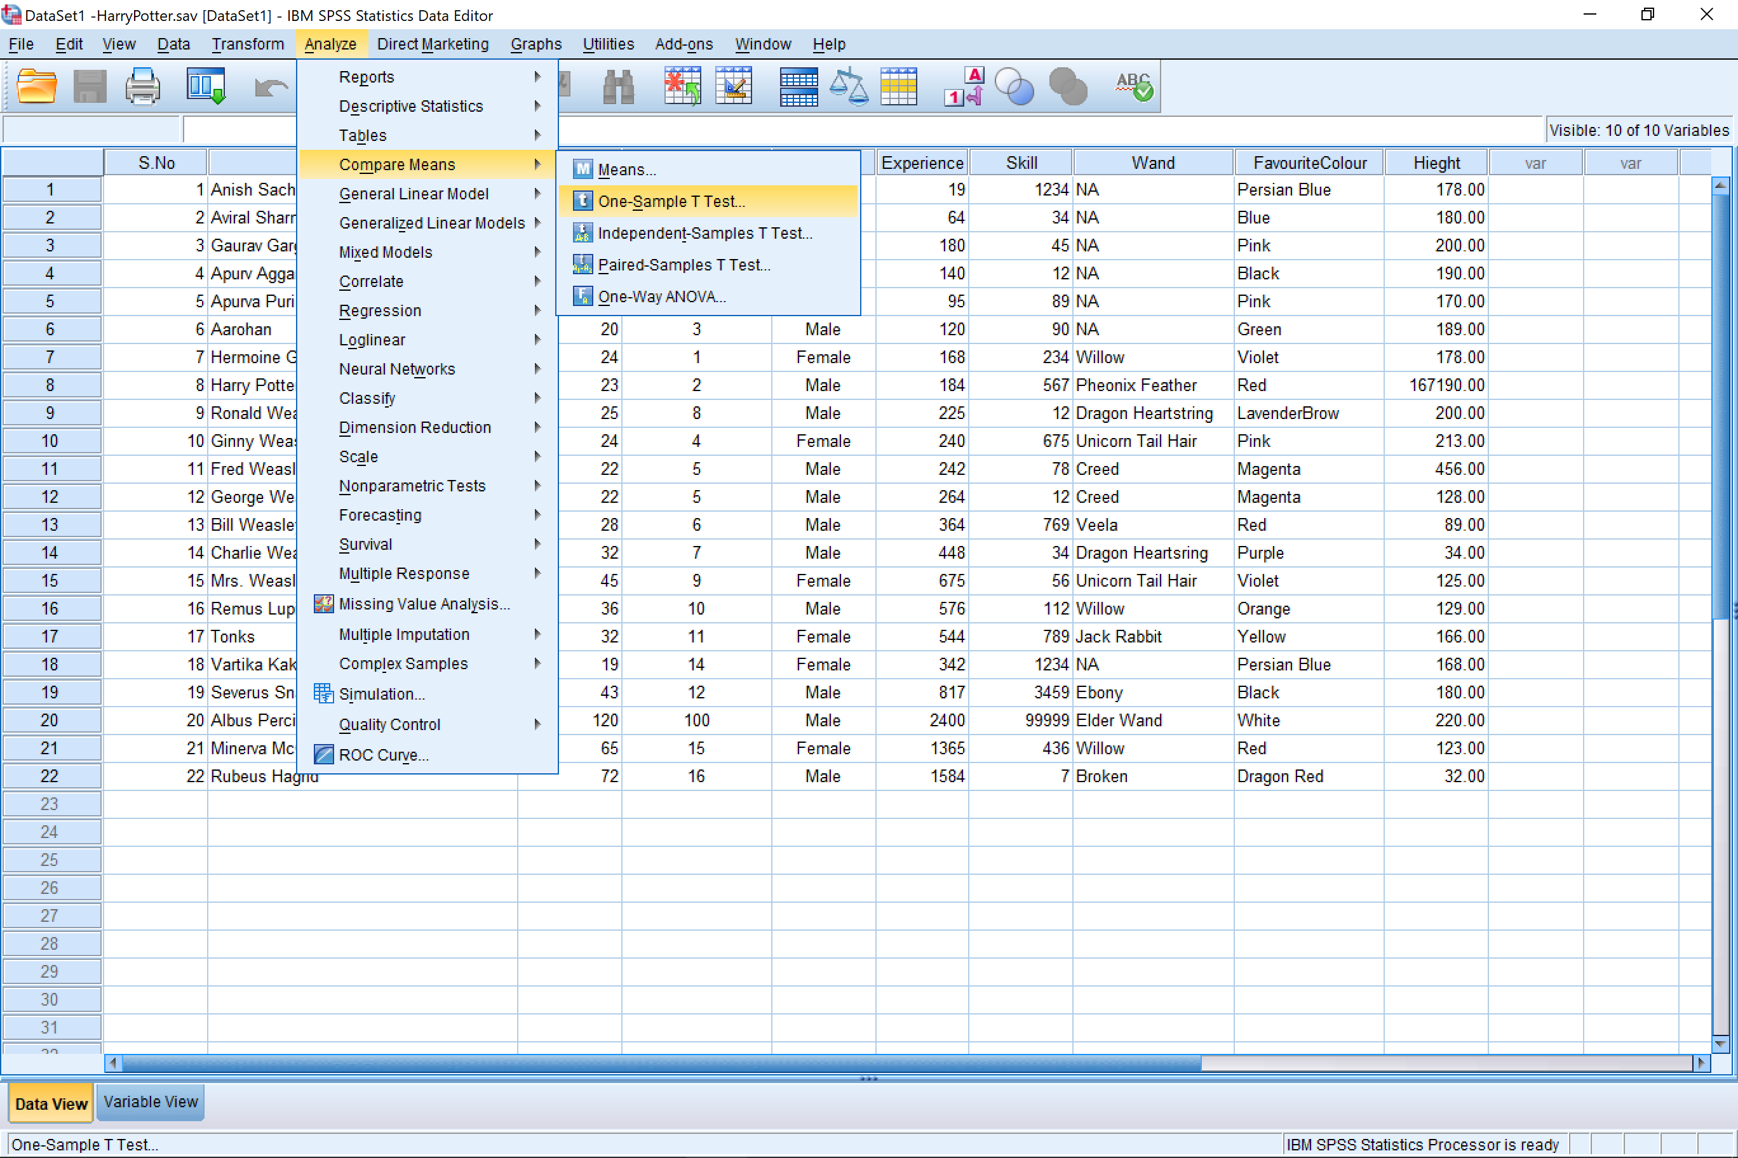

1. Then select the variable you wish to perform the test on.

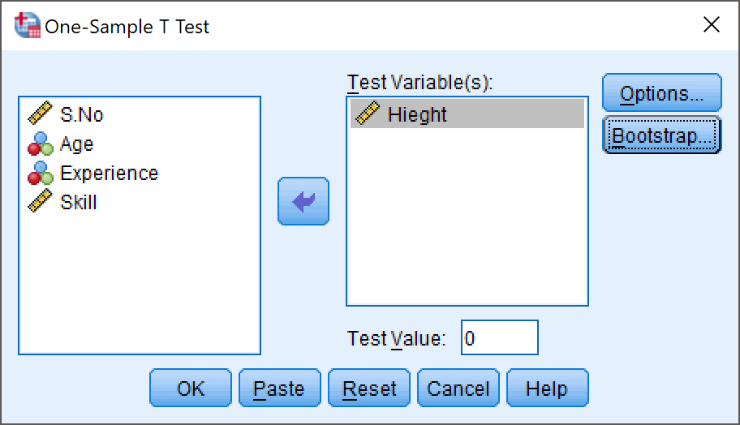

1. Select the ‘options’ tab from the dialog box to select the confidence level.

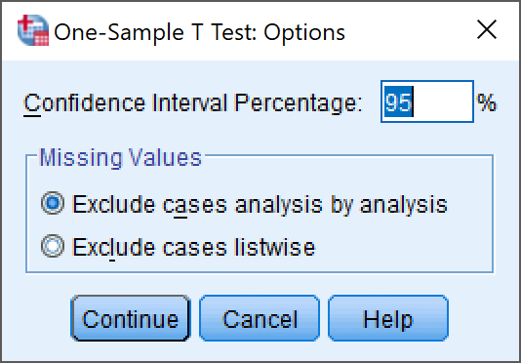

## Results

|  |  |  |  |  |
| --- | --- | --- | --- | --- |
| **One-Sample Statistics** | | | | |
|  | N | Mean | Std. Deviation | Std. Error Mean |
| Height | 22 | 7760.8182 | 35609.10115 | 7591.88587 |

|  |  |  |  |  |  |  |
| --- | --- | --- | --- | --- | --- | --- |
| **One-Sample Test** | | | | | | |
|  | Test Value = 0 | | | | | |
| t | df | Sig. (2-tailed) | Mean Difference | 95% Confidence Interval of the Difference | |
| Lower | Upper |
| Height | 1.022 | 21 | .318 | 7760.81818 | -8027.3728 | 23549.0092 |

# Paired-Sample T-Test

## Procedure

1. Analyze -> Compared Means -> Paired-Sample T-Test

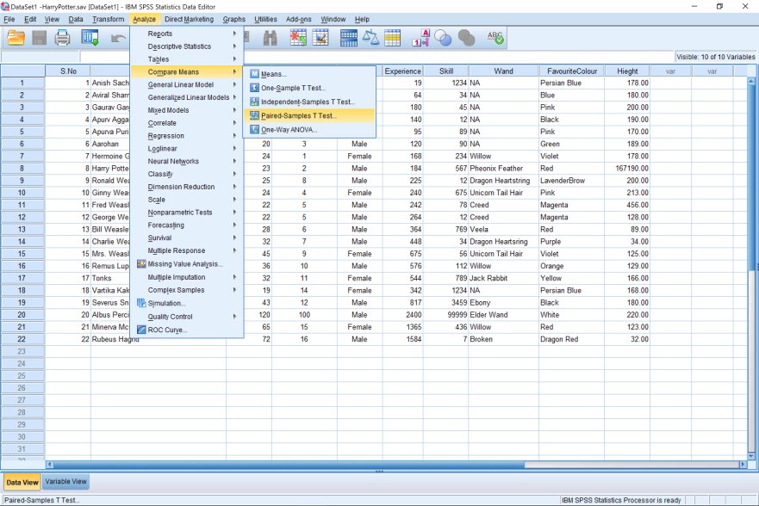

1. Then select the data in the form of pairs for analysis

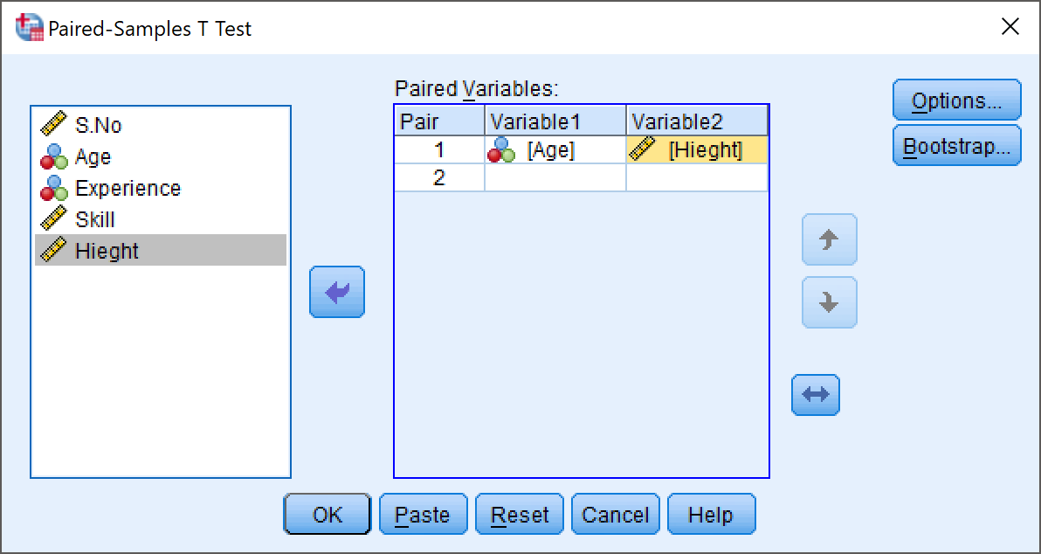

1. Now select the ‘options’ tab from the dialog box and select the confidence interval for the paired data set tat you have chosen.

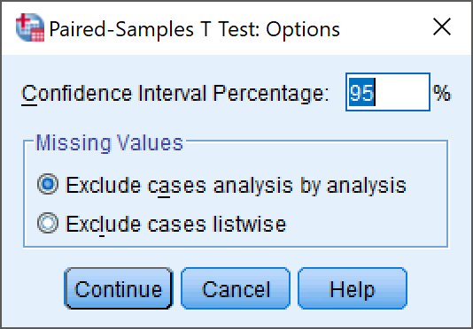

1. Now click on ‘continue’ in the Options Tab and ‘Ok’ I the main dialog box to create result.

## Results

|  |  |  |  |  |  |  |  |  |  |  |  |  |  |  |  |  |  |  |
| --- | --- | --- | --- | --- | --- | --- | --- | --- | --- | --- | --- | --- | --- | --- | --- | --- | --- | --- |
| **Paired Samples Statistics** | | | | | | | | | | | | | | | | | | |
|  | | | | Mean | | | | N | | | Std. Deviation | | | | Std. Error Mean | | | |
| Pair 1 | | Age | | 37.14 | | | | 22 | | | 23.981 | | | | 5.113 | | | |
| Hieght | | 7760.8182 | | | | 22 | | | 35609.10115 | | | | 7591.88587 | | | |
| **Paired Samples Correlations** | | | | | | | | | | | | | | | |
|  | | | | | | N | | | Correlation | | | Sig. | | | |
| Pair 1 | | Age & Hieght | | | | 22 | | | -.132 | | | .558 | | | |
| **Paired Samples Test** | | | | | | | | | | | | | | | | | | | | |
|  | | | | | Paired Differences | | | | | | | | | | | | | | | |
| Mean | | | | | Std. Deviation | | | | Std. Error Mean | | | | 95% Confidence Interval of the Difference | | |
| Lower | | |
| Pair 1 | Age - Hieght | | | | -7723.68182 | | | | | 35612.27359 | | | | 7592.56224 | | | | -23513.27937 | | |
| **Paired Samples Test** | | | | | | | | | | | | | | | | | | | | | |
|  | | | | | | | Paired Differences | | | | | | t | | | | df | | | Sig. (2-tailed) | |
| 95% Confidence Interval of the Difference | | | | | |
| Upper | | | | | |
| Pair 1 | | | Age - Hieght | | | | 8065.91574 | | | | | | -1.017 | | | | 21 | | | .321 | |

# Precautions

1. The data being selected either for One-Sample T-Test or Paired-Sample T-Test should be done so carefully, as that will affect the distribution attained.
2. The confidence interval should be chosen according to the question or problem at hand, and should emulate the situation we are simulating statistically.

# Conclusion

We conclude that SPSS Statistics software is capable of performing the T-Test for both single variables and Paired-Variables accurately at a given confidence level.

Objective 8: Anova Test